

DEPARTMENT OF COMPUTER SCIENCE AND ENGINEERING LAB MANUAL

CS23432 – Software Construction

(REGULATION 2023)

RAJALAKSHMI ENGINEERING COLLEGE
Thandalam, Chennai-602015

Name: Allwin Joseph A
Register No: 231801008
Year / Branch / Section: 2nd / AI&DS / FA Semester: IV
Academic Year: 2024 - 2025

INDEX

S.No. | Date | Title
1. | 21/1/25 | Azure Devops Environment Setup.
2. | 21/1/25 | Azure Devops Project Setup and User Story Management.
3. | 28/1/25 | Setting Up Epics, Features, And User Stories for Project Planning.
4. | 11/2/25 | Sprint Planning.
5. | 18/2/25 | Poker Estimation.
6. | 25/2/25 | Designing Class and Sequence Diagrams for Project Architecture.
7. | 04/3/25 | Designing Architectural and ER Diagrams for Project Structure.
8. | 25/3/25 | Testing – Test Plans and Test Cases.
9. | 15/4/25 | Load Testing and Pipelines.
10. | 22/4/25 | GitHub: Project Structure & Naming Conventions.

AZURE DEVOPS ENVIRONMENT SETUP

EXP NO: 1

Aim:
Create Epic, Features, User Stories, Task
To set up and access the Azure DevOps environment by creating an organization through the Azure portal.

INSTALLATION
- Open your web browser and go to the Azure website: https://azure.microsoft.com/en-us/get- started/azure-portal.
Sign in using your Microsoft account credentials.
If you don't have a Microsoft account, you can create one here: https://signup.live.com/?lic=1
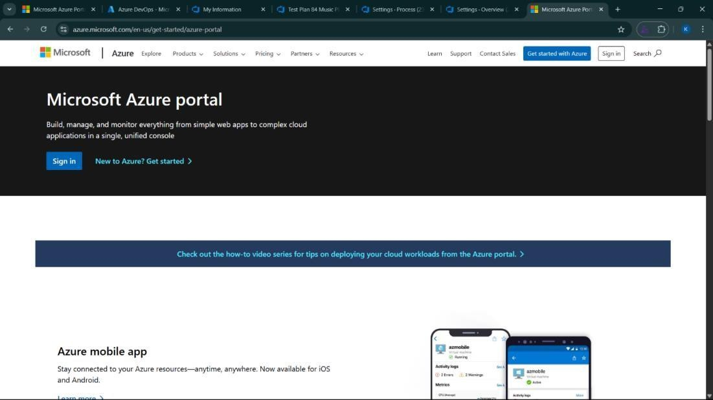

- Azure home page
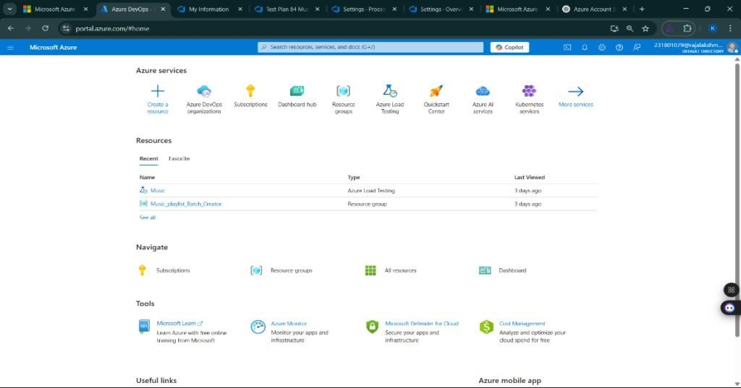
- Open DevOps environment in the Azure platform by typing Azure DevOps Organizations in the search bar.
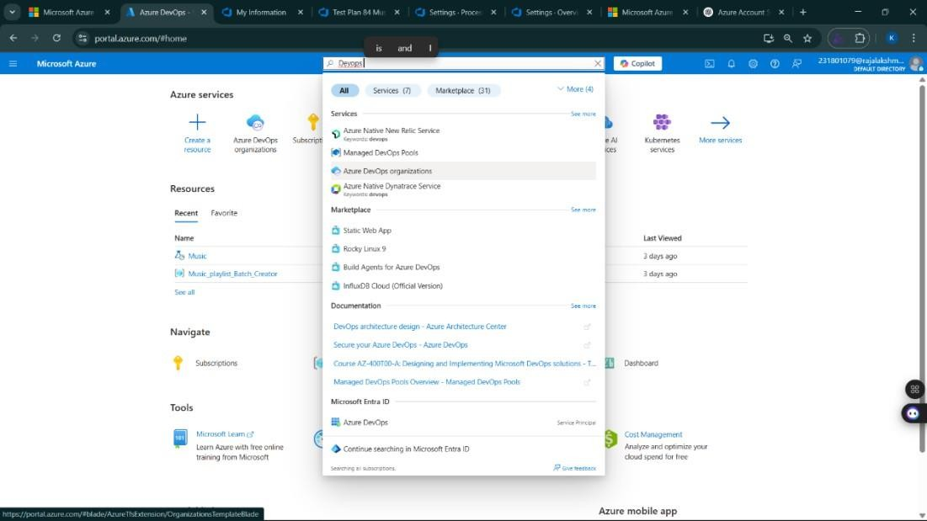

- Click on the My Azure DevOps Organization link and create an organization and you should be taken to the Azure DevOps Organization Home page.

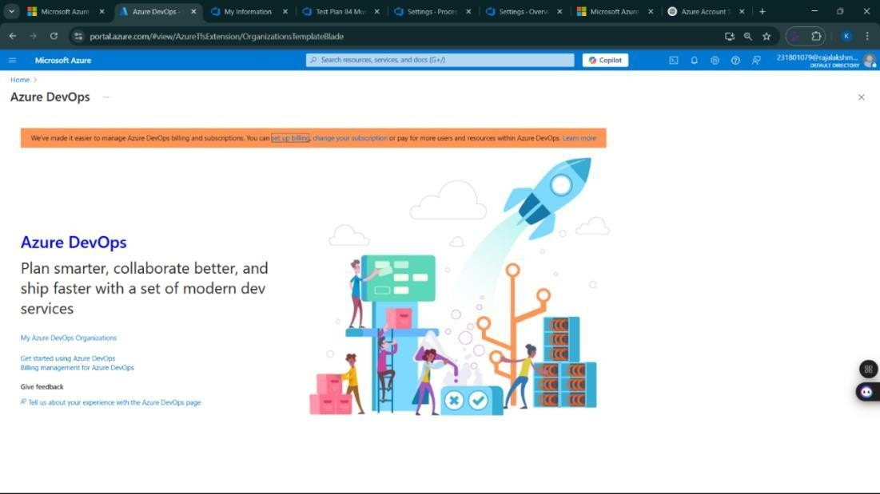

Result:
Successfully accessed the Azure DevOps environment and created a new organization through the Azure portal.

AZURE DEVOPS PROJECT SETUP AND USER STORY MANAGEMENT

EXP NO: 2

Aim:
Create Epic, Features, User Stories, Task
To set up an Azure DevOps project for efficient collaboration and agile work management.

- Create An Azure Account
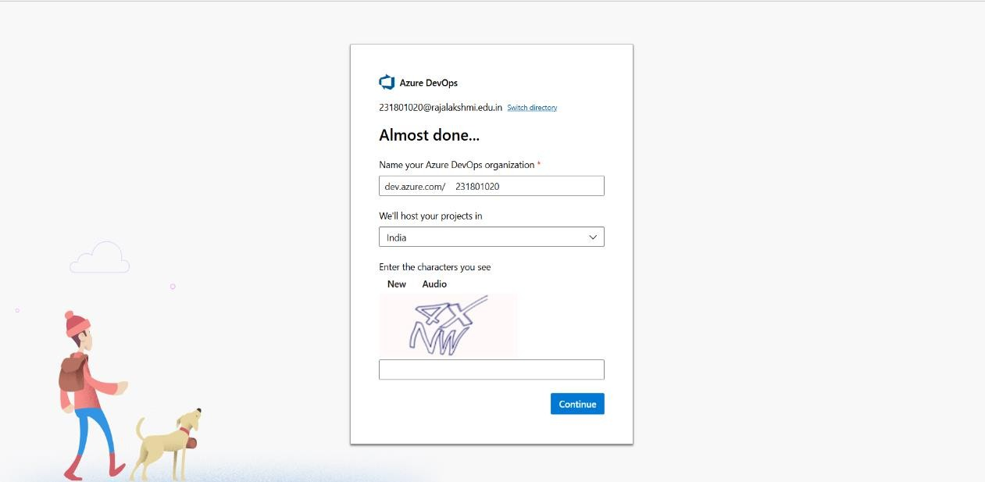

- Create the First Project in Your Organization
  - After the organization is set up, you’ll need to create your first project. This is where you'll begin to manage code, pipelines, work items, and more.
  - On the organization’s Home page, click on the New Project button.
  - Enter the project name, description, and visibility options:
Name: Choose a name for the project (e.g., HMS).
Description: Optionally, add a description to provide more context about the project. Visibility: Choose whether you want the project to be Private (accessible only to those invited) or Public (accessible to anyone).
  - Once you’ve filled out the details, click Create to set up your first project.

- Once logged in, ensure you are in the correct organization. If you're part of multiple organizations, you can switch between them from the top left corner (next to your user profile). Click on the Organization name, and you should be taken to the Azure DevOps Organization Home page.

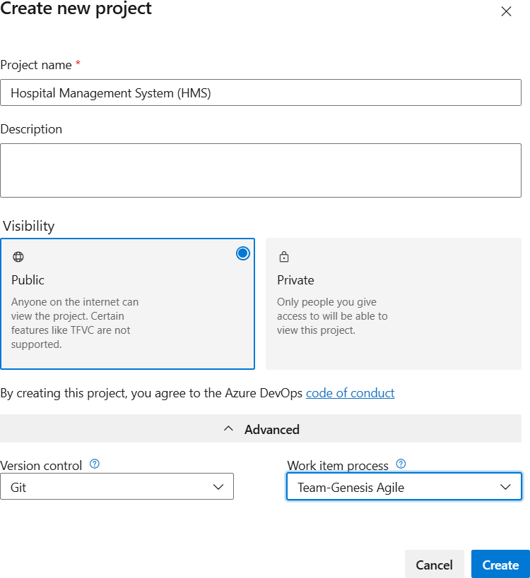

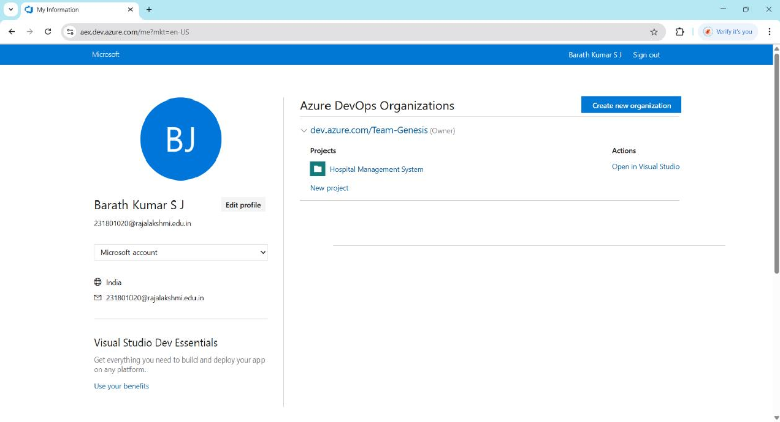

- Project dashboard
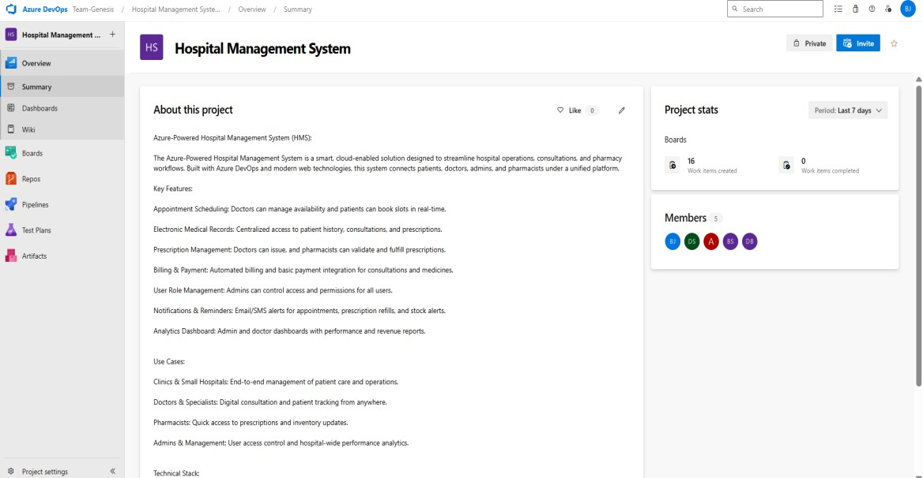

- To manage user stories:
  - From the left-hand navigation menu, click on Boards. This will take you to the main Boards
page, where you can manage work items, backlogs, and sprints.
  - On the work items page, you'll see the option to Add a work item at the top. Alternatively, you can find a + button or Add New Work Item depending on the view you're in. From the Add a work item dropdown, select User Story. This will open a form to enter details for the new User Story.

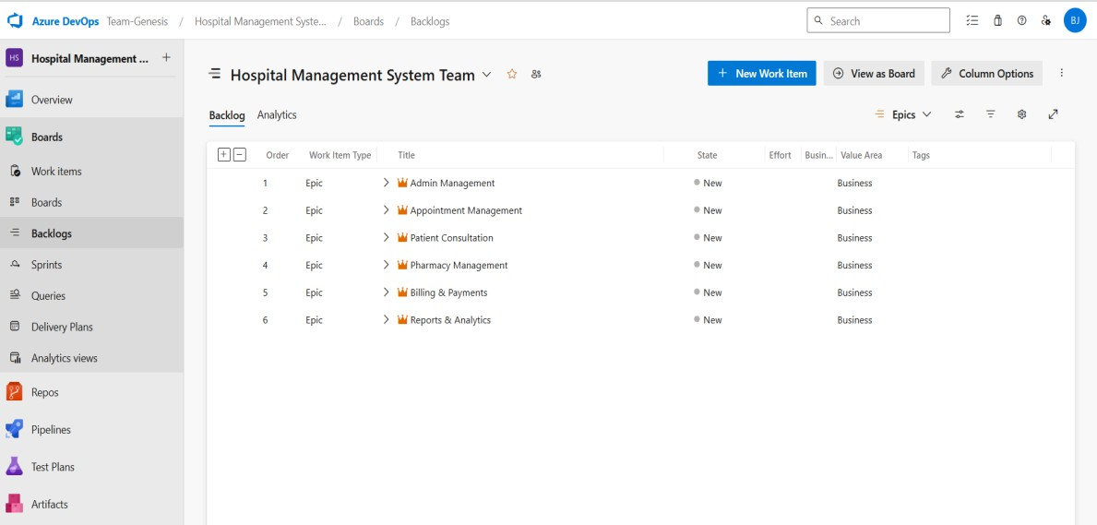

Result:
Successfully created an Azure DevOps project with user story management and agile workflow
setup.

SETTING UP EPICS, FEATURES, AND USER STORIES FOR PROJECT PLANNING

EXP NO: 3
Aim:
Create Epic, Features, User Stories, Task
To learn about how to create epics, user story, features, backlogs for your assigned project.

Create Epic, Features, User Stories, Task
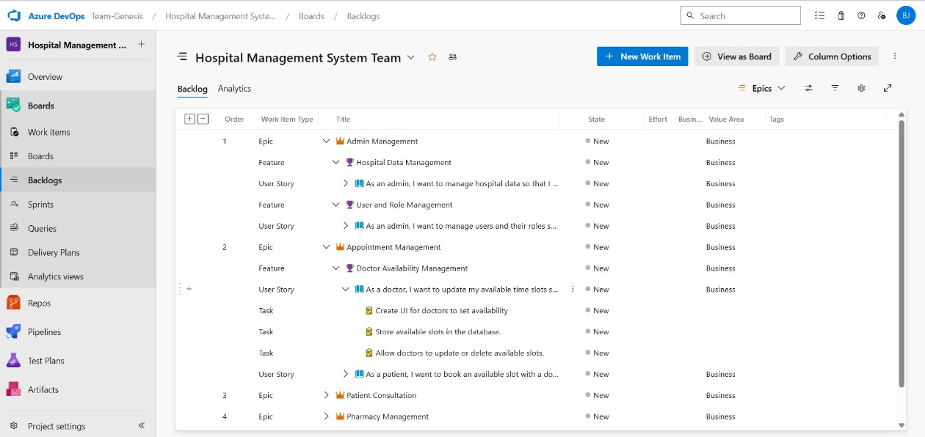

- Fill in Epics

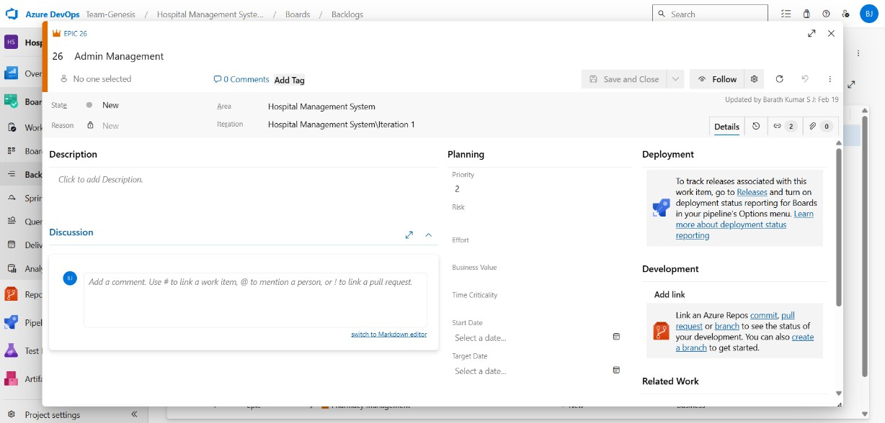

- Fill in Features
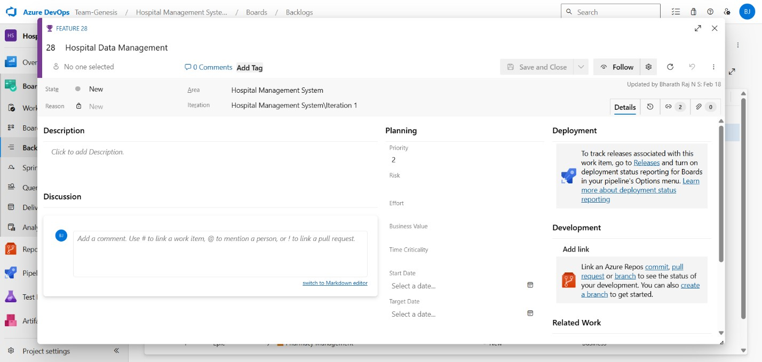

- Fill in User Story Details

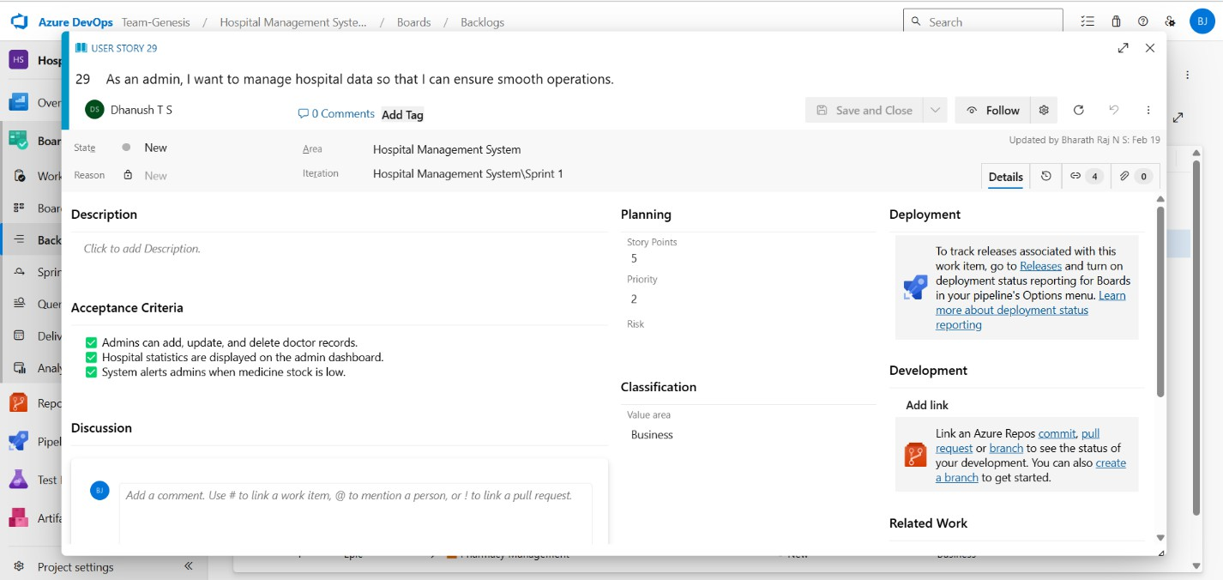

Result:
Thus, the creation of epics, features, user story and task has been created successfully.

SPRINT PLANNING

EXP NO: 4

Aim:
Create Epic, Features, User Stories, Task
To assign user story to specific sprint for the HMS Project.

Sprint Planning: Sprint 1
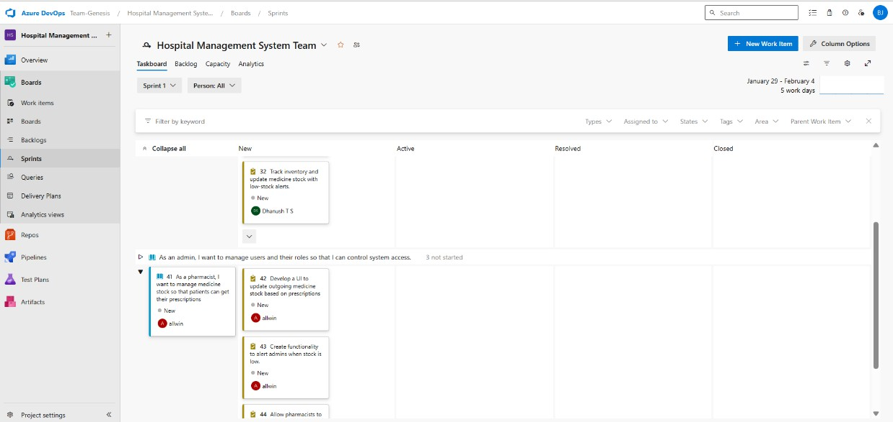
Sprint 2
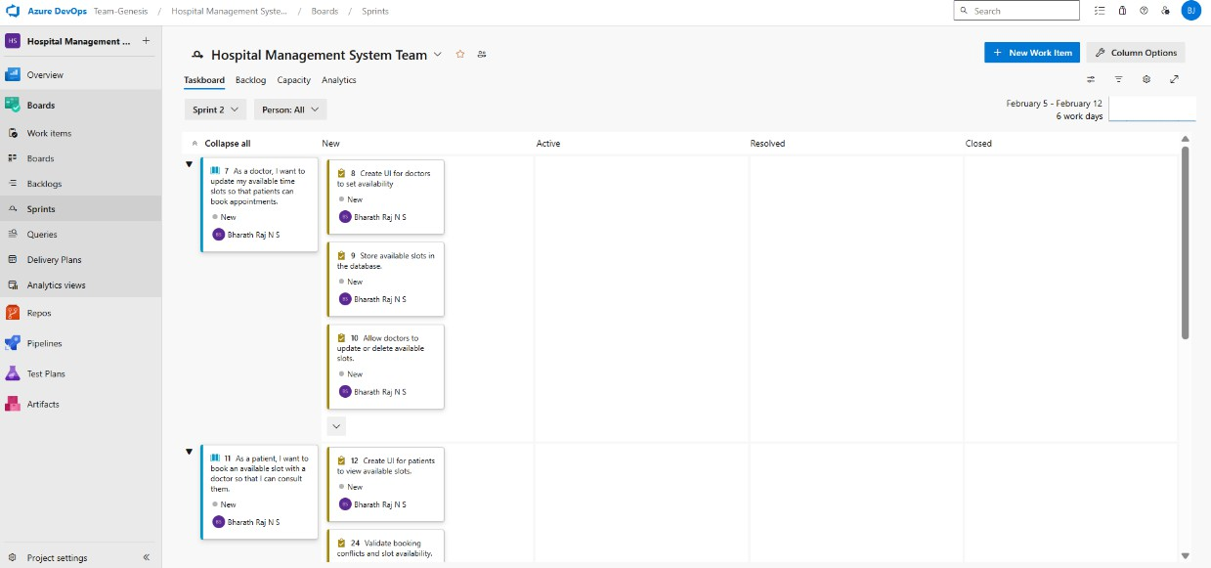

Sprint 3
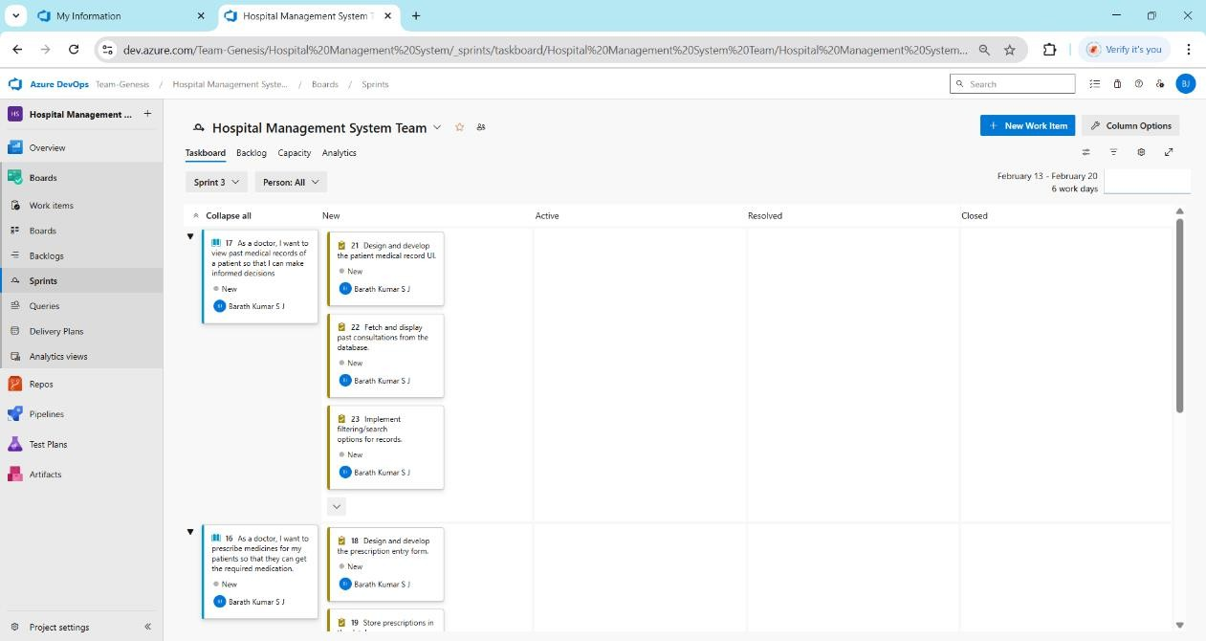
Sprint 4
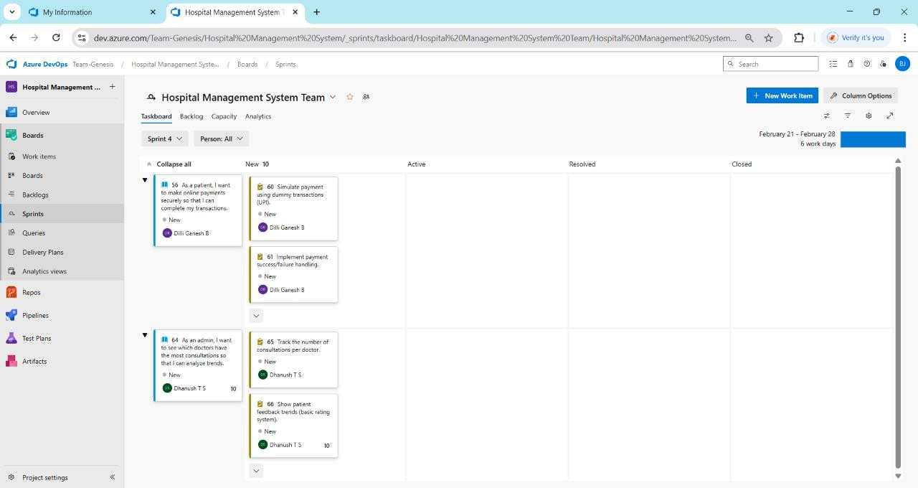

Result:
The Sprints are created for the Hospital Management System Project.

POKER ESTIMATION

EXP NO: 5

Aim:
Create Epic, Features, User Stories, Task
Create Poker Estimation for the user stories – Hospital Management System Project.

Poker Estimation

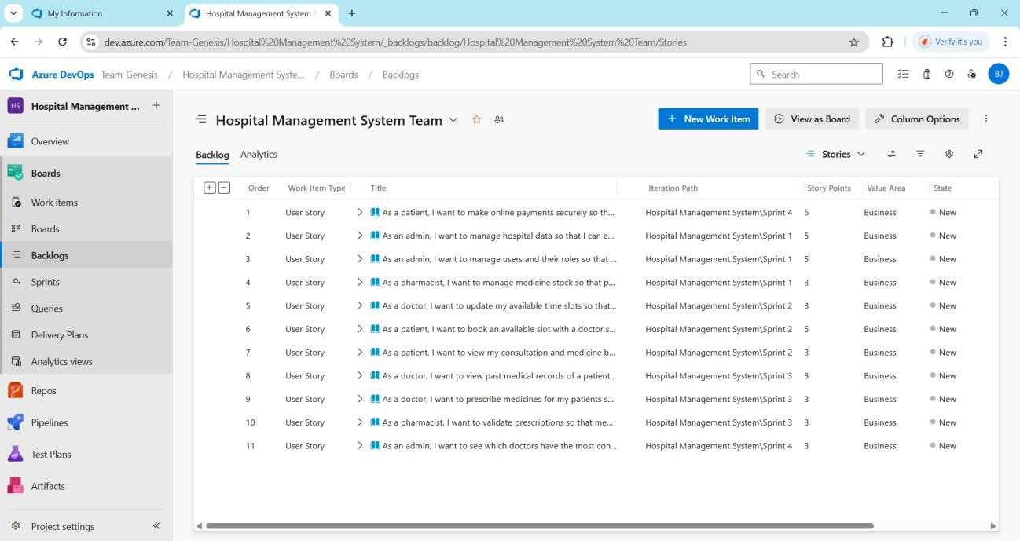

Result:
The Estimation/Story Points is created for the project using Poker Estimation.

DESIGNING CLASS AND SEQUENCE DIAGRAMS FOR PROJECT ARCHITECTURE

EXP NO: 6

Aim:
Create Epic, Features, User Stories, Task
To Design a Class Diagram and Sequence Diagram for the given Project.

6A. Class Diagram
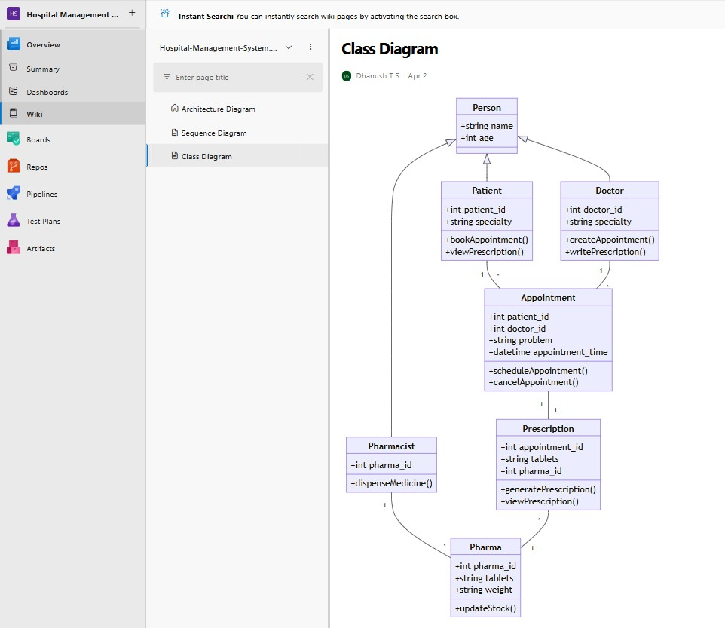

6B. Sequence Diagram
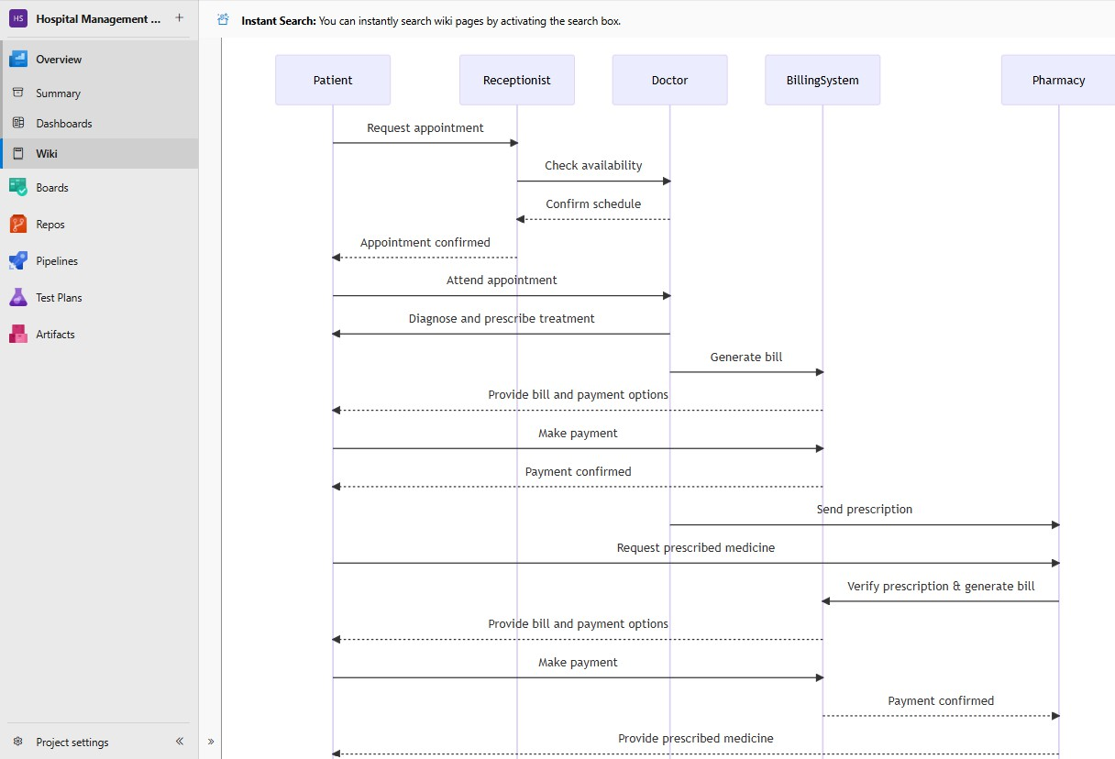

Result:

System.

The Class Diagram and Sequence Diagram is designed Successfully for the Hospital Management

DESIGNING ARCHITECTURAL AND ER DIAGRAMS FOR PROJECT STRUCTURE

EXP NO: 7

Aim:
Create Epic, Features, User Stories, Task
To Design an Architectural Diagram and ER Diagram for the given Project.
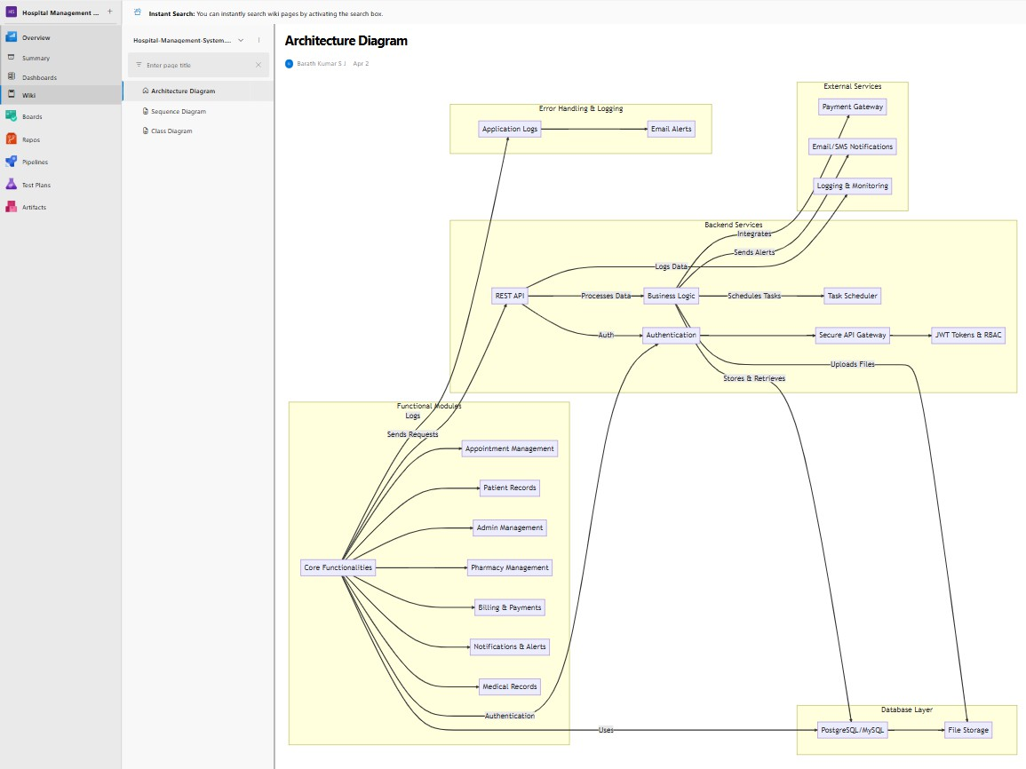
7A. Architectural Diagram
7B. ER Diagram
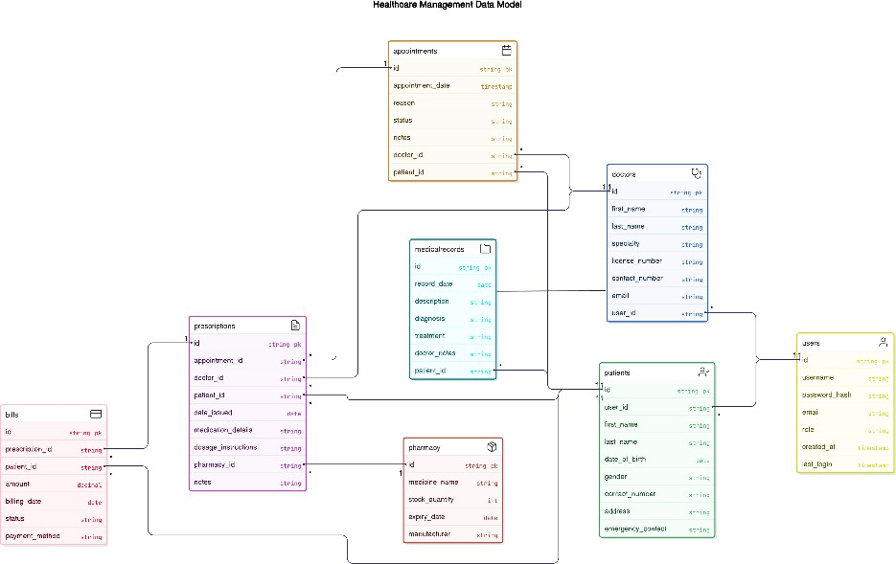

Result:

The Architecture Diagram and ER Diagram is designed Successfully for the Hospital Management System.

TESTING – TEST PLANS AND TEST CASES

EXP NO: 8
Aim:
Create Epic, Features, User Stories, Task
Test Plans and Test Case and write two test cases for at least five user stories showcasing the
happy path and error scenarios in azure DevOps platform.

Test Planning and Test Case Test Case Design Procedure
- Understand Core Features of the Application
  - User Signup & Login (Patient, Doctor, Admin)
  - Appointment Booking and Availability Management
  - Patient Medical Record Viewing and Prescription Entry
  - Admin Dashboard for Hospital Data and User Management
  - Pharmacy Module for Prescription Fulfillment and Stock Tracking
- Define User Interactions
  - Each test case simulates a real user behaviour (e.g., Patients booking appointments, Doctors updating availability and prescribing medicines, Admins managing doctor records and stock levels).
- Design Happy Path Test Cases
  - These test cases validate correct functioning under expected conditions:
  - Successful login for each user role
  - Patient books an available appointment
  - Doctor views medical history and writes a prescription
  - Pharmacist fulfills a valid prescription
- Design Error Path Test Cases
  - These test cases simulate negative or invalid flows:
  - Login fails with wrong password
  - Patient attempts to book a past/unavailable slot
  - Doctor tries to access non-existent patient data
  - Admin tries to delete a locked record
- Break Down Steps and Expected Results
  - Each test case contains step-by-step actions and a corresponding expected outcome.
  - Ensures clarity for both testers and automation scripts.
- Use Clear Naming and IDs
  - Test cases are named clearly (e.g., TC01 – Patient Successful Login, TC02 – Invalid Slot Booking).
  - Mapped to relevant user stories and features in Azure DevOps Boards.
  - Helps in quick identification and linking to user stories or features.
- Separate Test Suites
  - Test cases are grouped by functional modules:
  - Login & Authentication
  - Appointment Management
  - Consultation & Prescriptions
  - Admin & Role Management
  - Pharmacy Management
- Prioritize and Review
- Critical functions like login, appointment booking, and prescription management are prioritized
- Test cases are reviewed for completeness, clarity, and traceability to project requirement

- New test plan
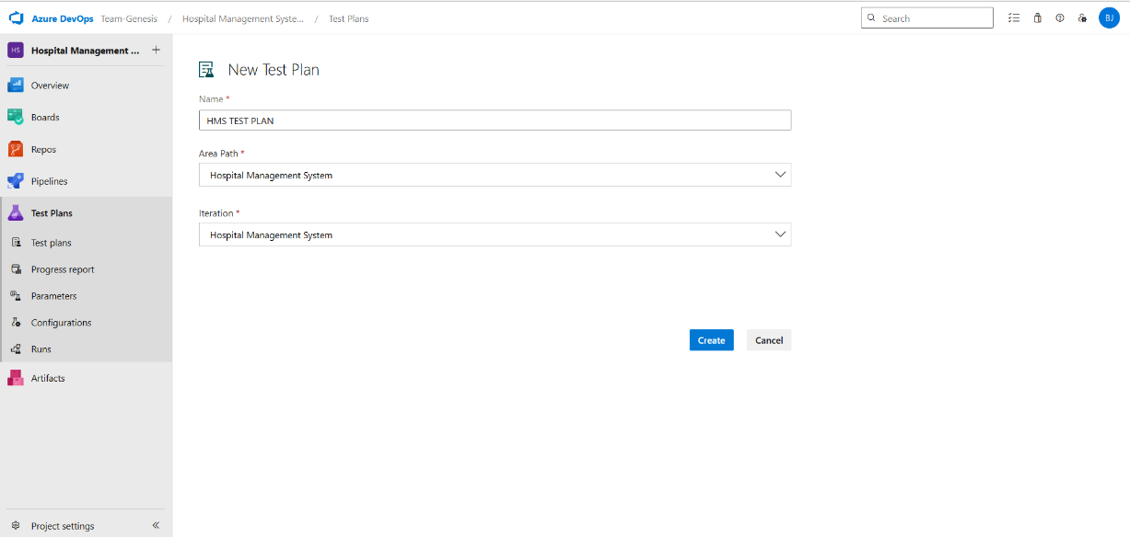

- Test suite
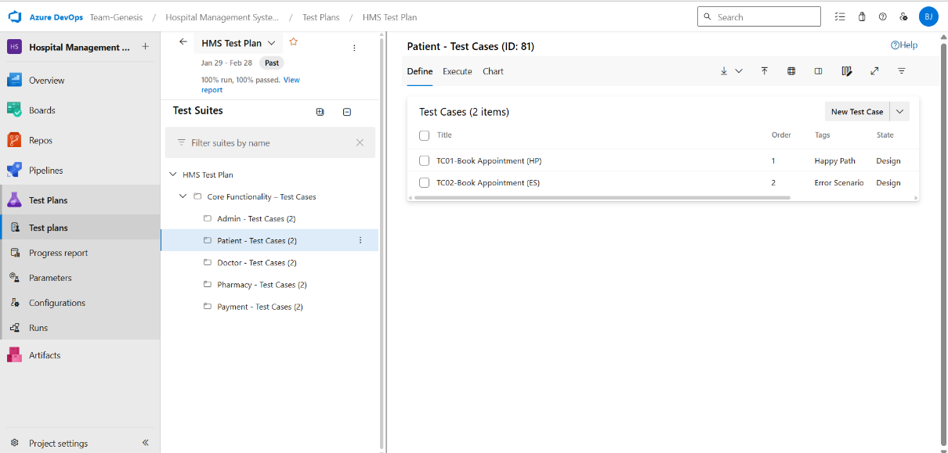

- Test case
Give two test cases for at least five user stories showcasing the happy path and error scenarios in azure DevOps platform.
HMS – Test Plans
USER STORIES
- As a doctor, I want to update my available time slots so that patients can book appointments.
- As a patient, I want to book an available slot with a doctor so that I can schedule a consultation.
- As a doctor, I want to prescribe medicines so that patients can get required treatment.
- As an admin, I want to manage users and assign roles so that access control is maintained
- As a pharmacist, I want to fulfill prescriptions so that patients can receive medicines.
Test Suites
Test Suit: TS01 - Doctor Availability Management
- TC01 – Set Availability Successfully
  - Action:
    - Login as Doctor
    - Navigate to “Set Availability”
    - Choose valid date and time slots.
    - Click "Save".
  - Expected Results:
    - Availability slots are saved and listed.
    - Fields accept values without error.
  - Type: Happy Path
- TC02 – Save Without Selecting Slot
  - Action:
    - Login as Doctor
    - Go to “Set Availability”
    - Click “Save” without selecting slot
  - Expected Results:
    - Error: “Please select a time slot.”
  - Type: Error Path

- TC03 – Sign Up with Existing Email
  - Action:
    - Go to the Sign-Up page.
    - Enter a name and an already registered email.
    - Click on "Sign Up".
  - Expected Results:

    - Fields accept data.
    - Error message "Email already registered" is displayed.
  - Type: Error Path

Test Suit: TS02 - Appointment Booking
- TC04 – Patient Books Valid Appointment
  - Action:
    - Log in successfully.
    - View available doctors and slot
    - Select slot and click “Book”
  - Expected Results:
    - Booking confirmation shown.
  - Type: Happy Path
- TC05 – Booking Unavailable Slot
  - Action:
    - Try booking an already-booked or past slot.
  - Expected Results:
    - Error: “Slot unavailable or expired.”
  - Type: Error Path

Test Suit: TS03 - Prescription Management
- TC06 – Doctor Prescribes Medicines
  - Action:
    - Login as Doctor
    - Open patient consultation
    - Add medicines and dosage
    - Click“Submit”
  - Expected Results:
    - Prescription saved and shown in record
  - Type: Happy Path
- TC07 – Prescription Without Medicines
  - Action:

    - Try submitting prescription form without entering medicine details
  - Expected Results:
    - Error: “Medicine field cannot be empty.”
  - Type: Error Path

Test Suit: TS04 - Admin Role Management
- TC08 – Assign Role to User
  - Action:
    - Login as Admin
    - Go to “User Management”
    - Select a user and assign role (doctor/patient/pharmacist)
  - Expected Results:
    - Role updated successfully.
  - Type: Happy Path
- TC09 – Assign Role to Invalid User
  - Action:
    - Try assigning a role to a non-existing or deleted user
  - Expected Results:
    - Error: “User not found.”
  - Type: Error Path

Test Suit: TS05 - Prescription Fulfillment (Pharmacy)
- TC10 – Fulfill Prescription
  - Action:
    - Login as Pharmacist
    - View assigned prescriptions
    - Mark as fulfilled and issue medicine
  - Expected Results:
    - Status updated: "Fulfilled".
  - Type: Happy Path
- TC11 – Fulfill Without Prescription
  - Action:
    - Try fulfilling without selecting a prescription
  - Expected Results:
    - Error message: “No prescription selected.”.
  - Type: Error Path

Test Cases
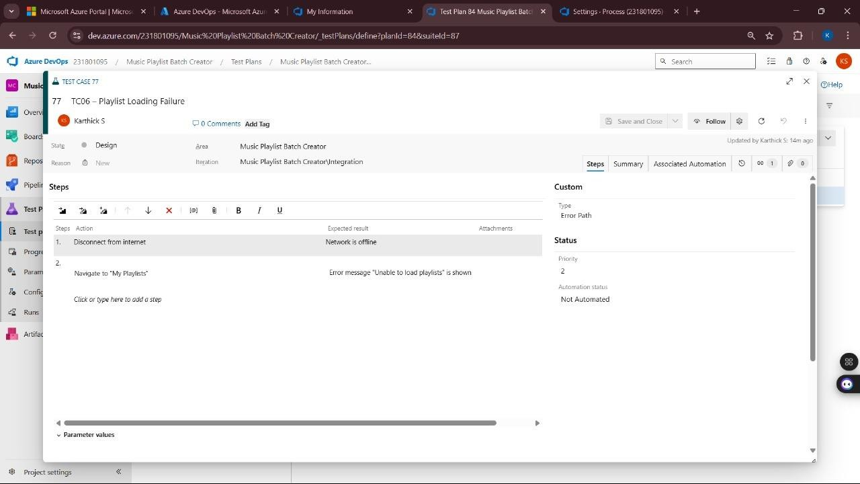

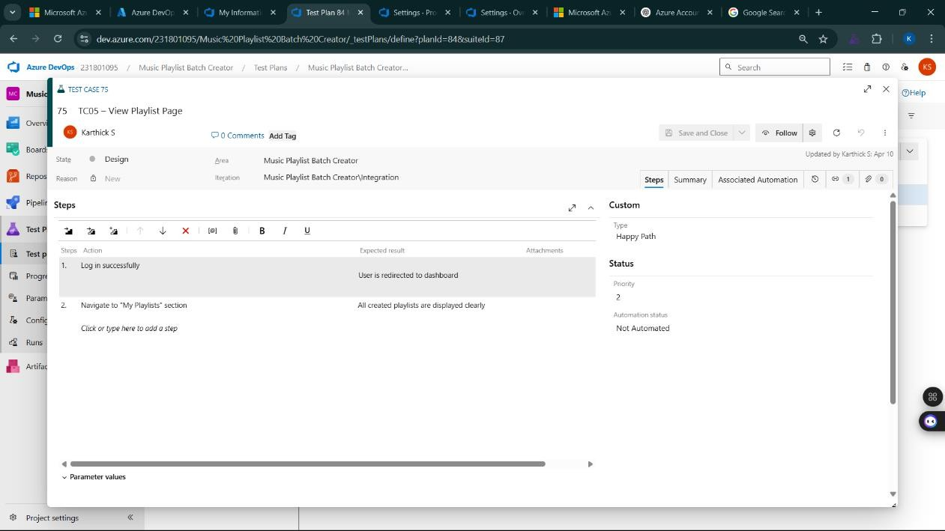
- Installation of test
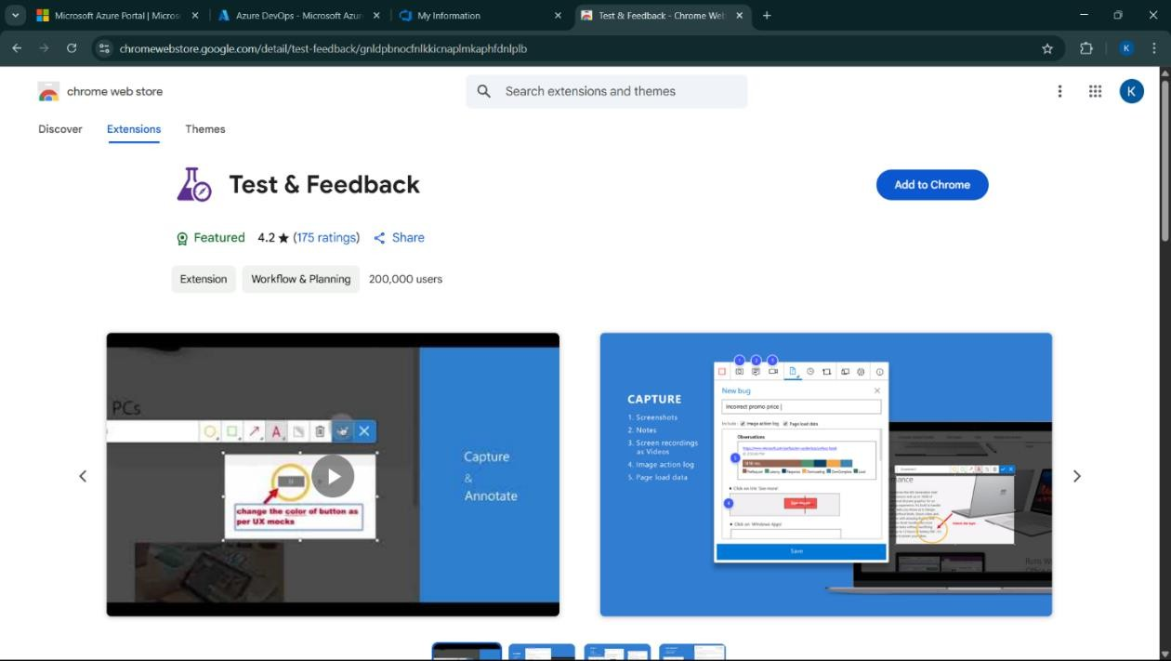

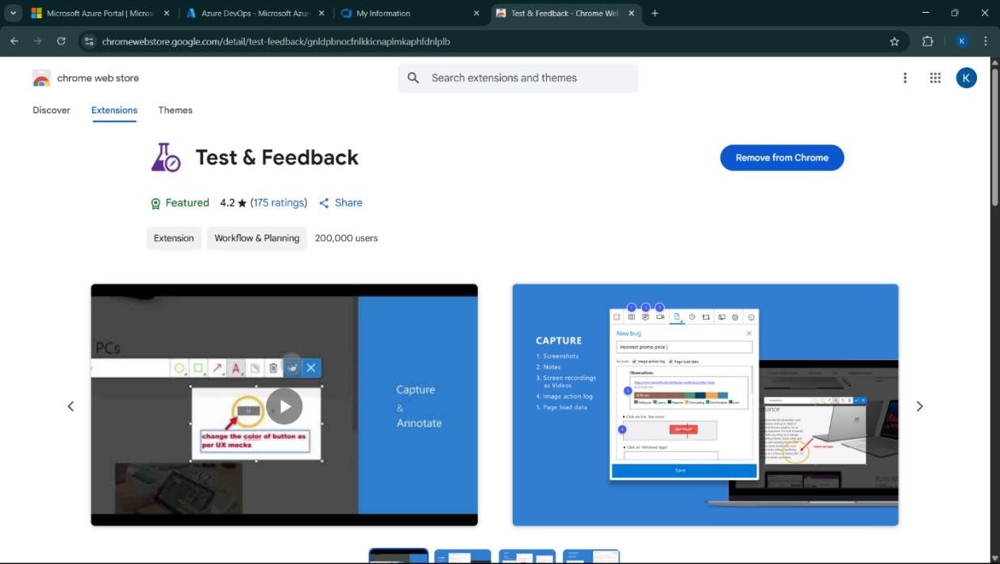

Test and feedback Showing it as an extension
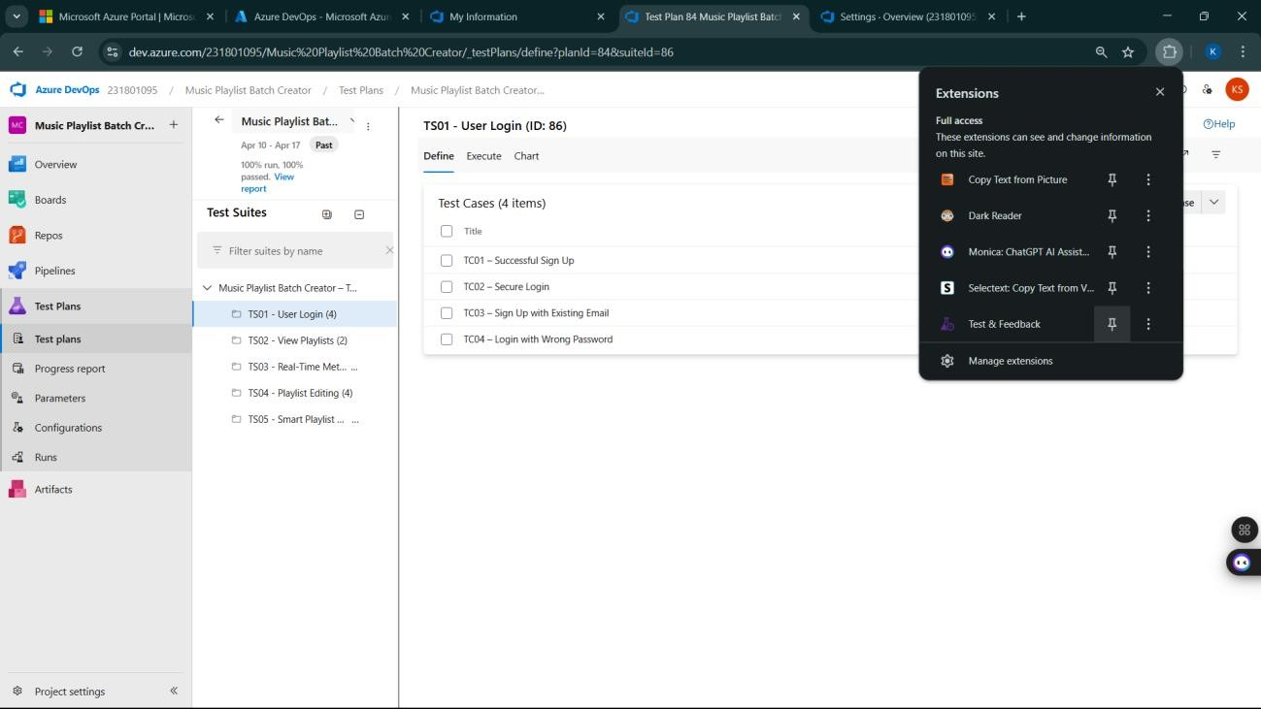

- Running the test cases
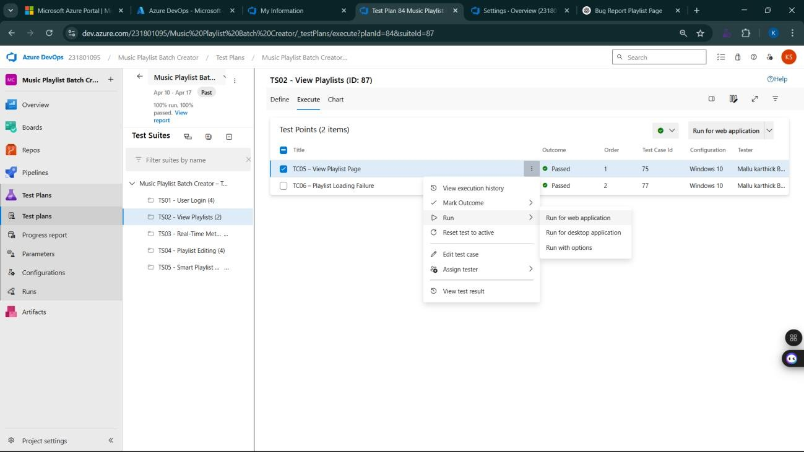
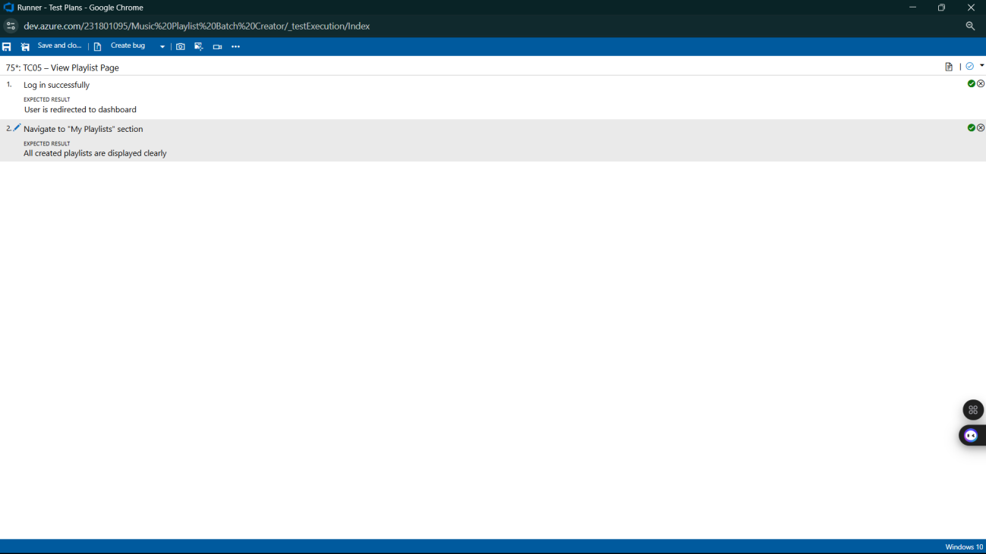

- Recording the test case
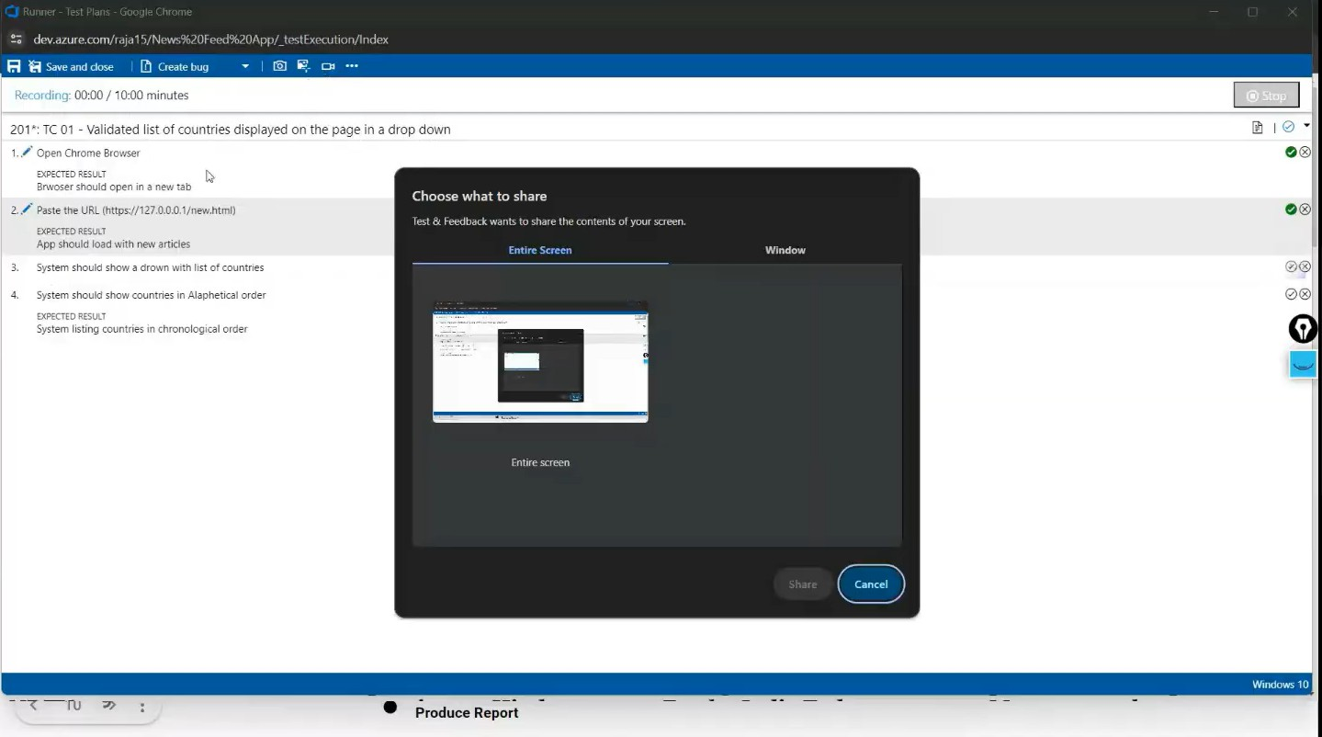

- Creating the bug
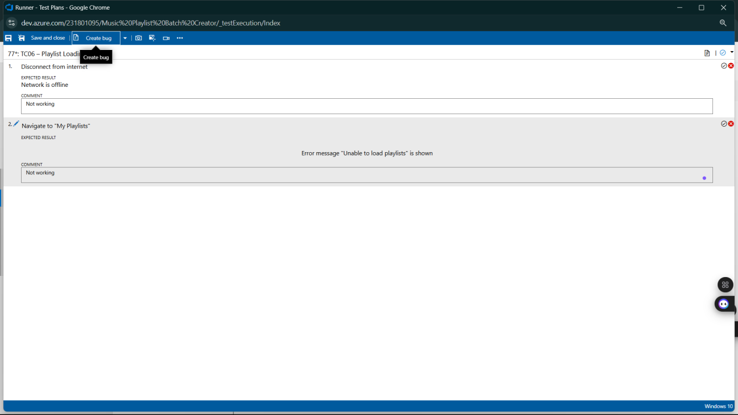

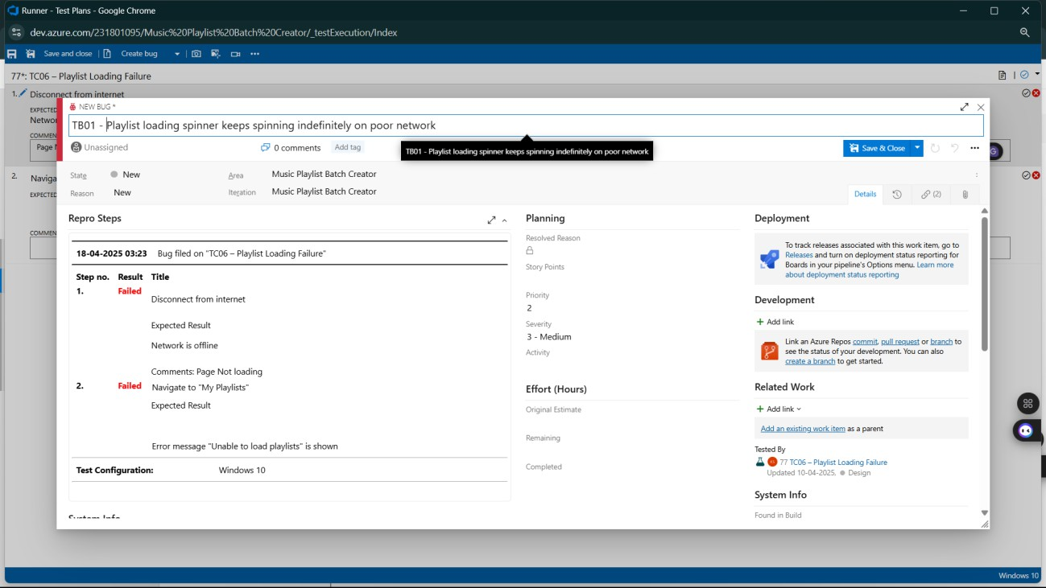
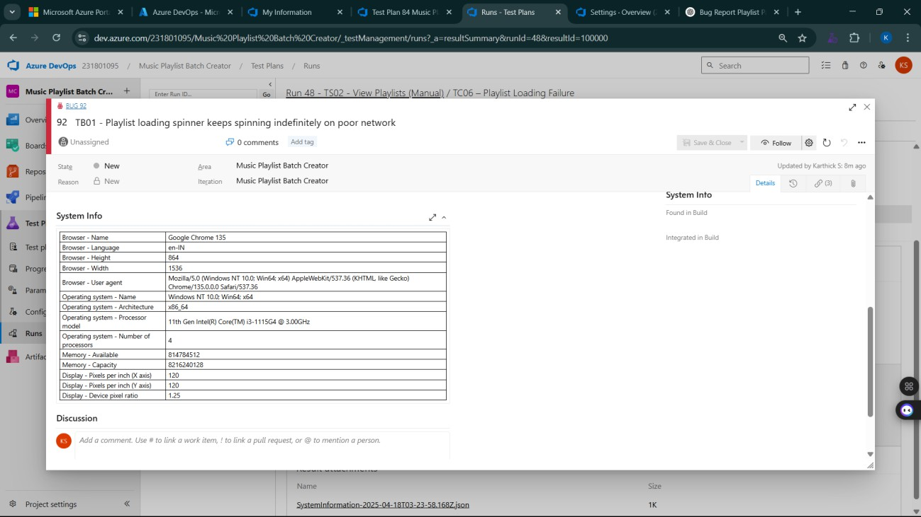

- Test case results
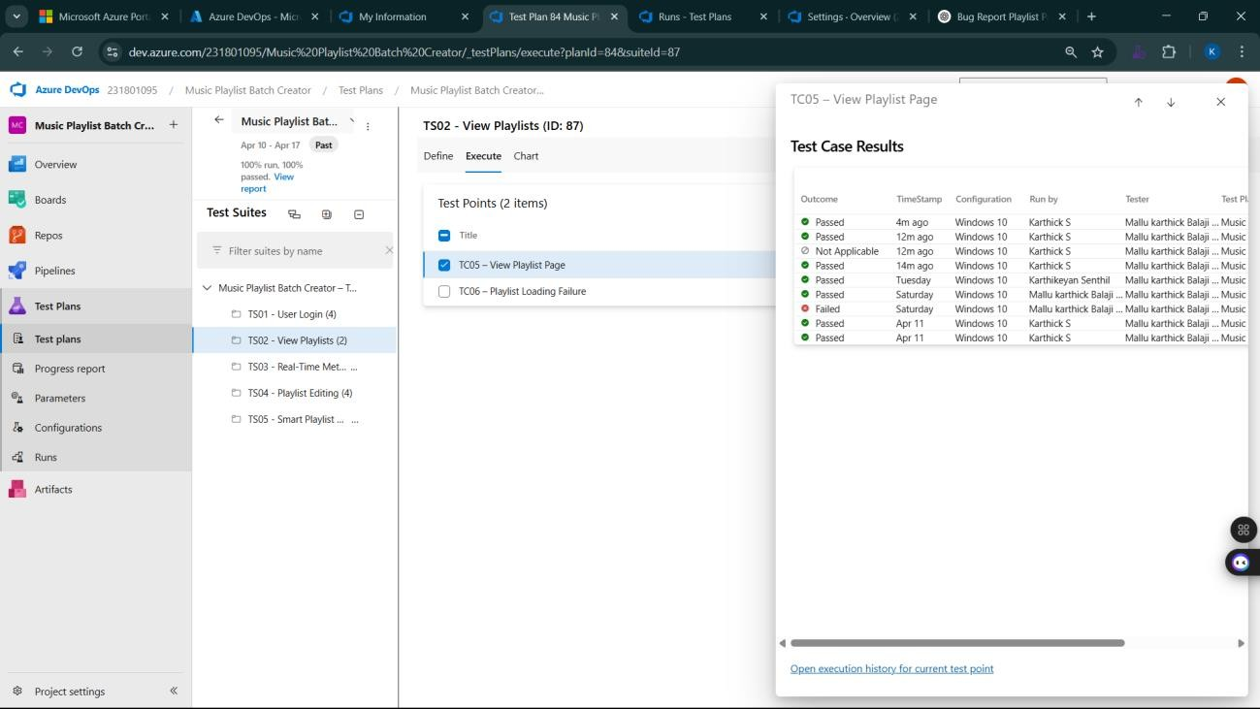

- Test report summary
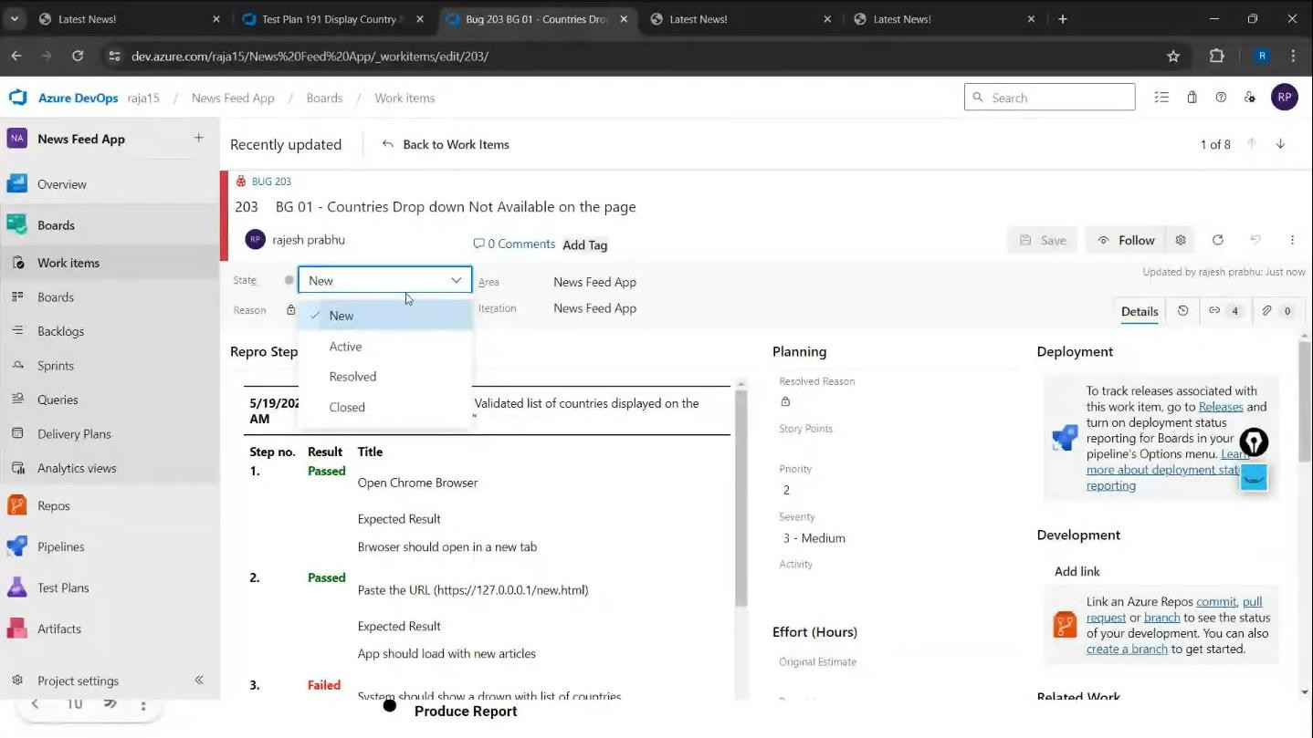

  - Assigning bug to the developer and changing state

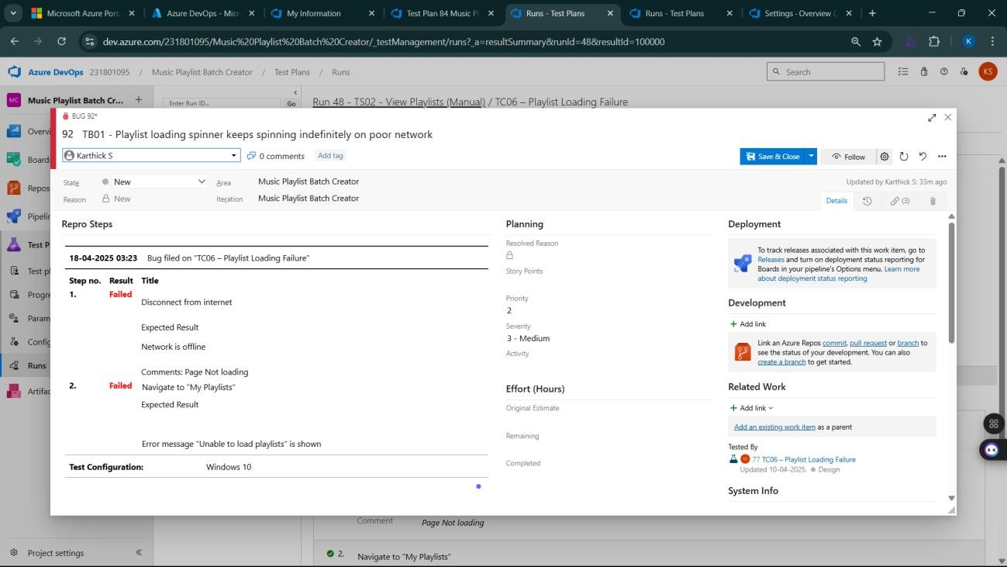

- Progress report
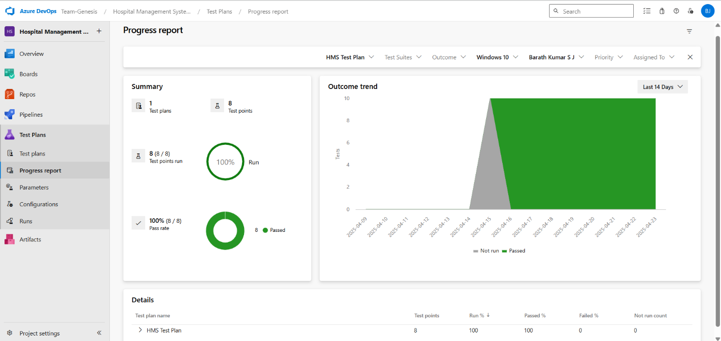

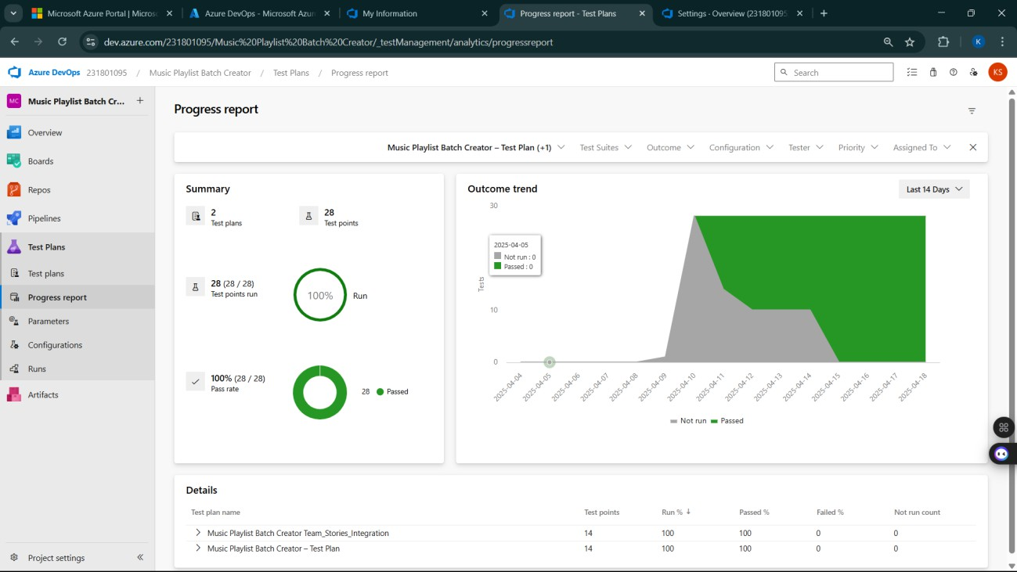

- Changing the test template
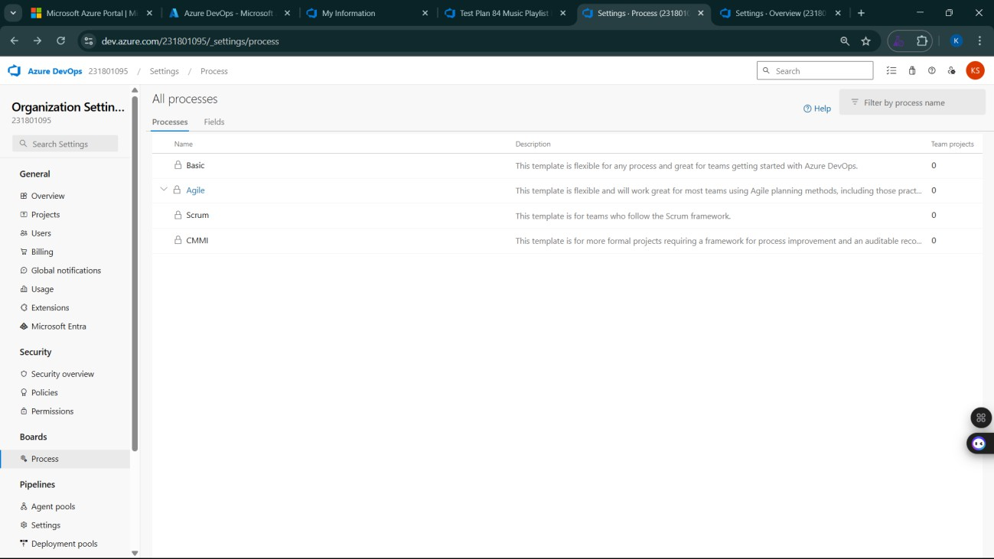

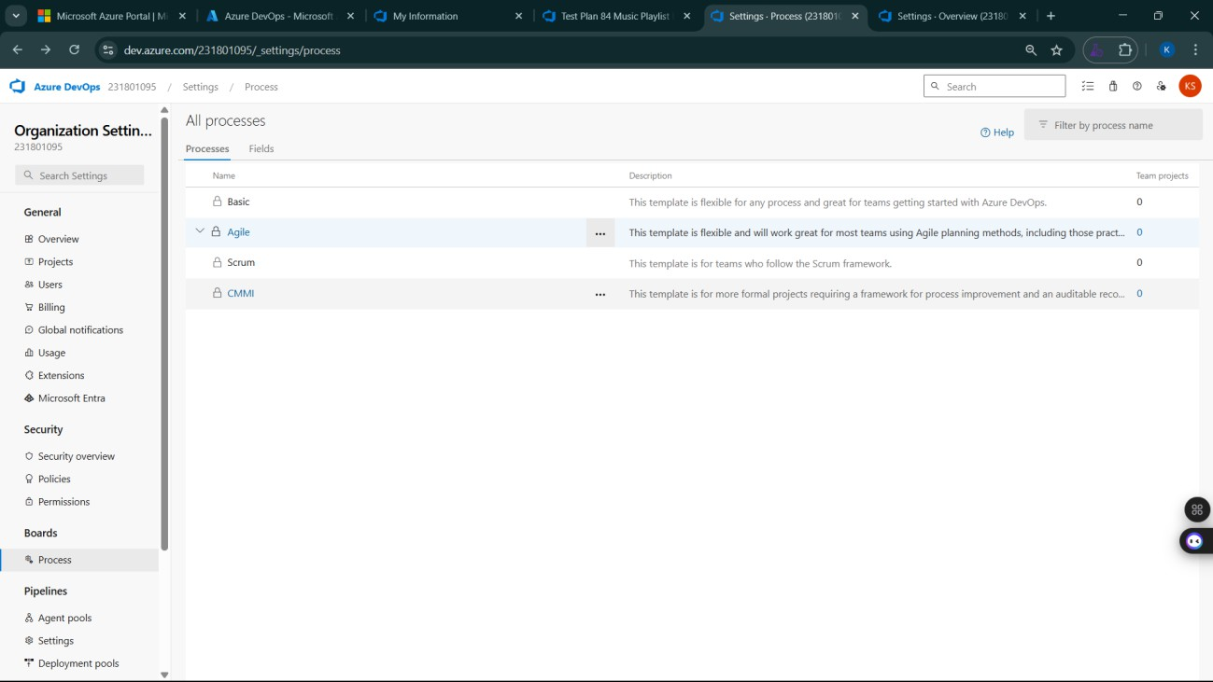
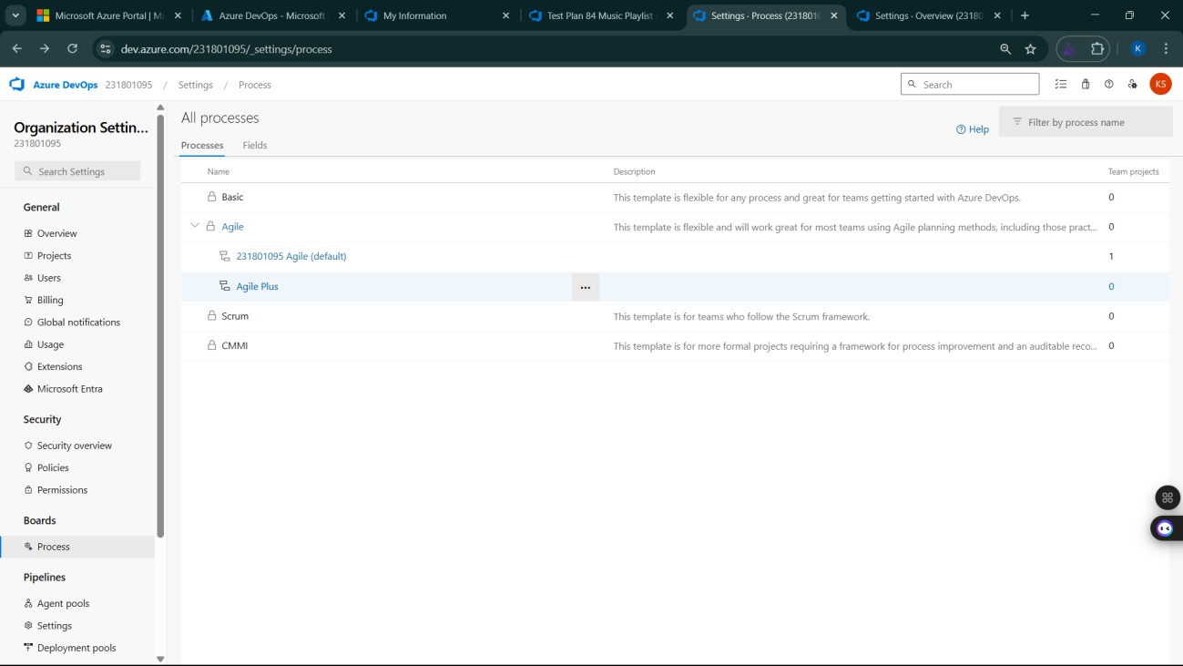

- View the new test case template
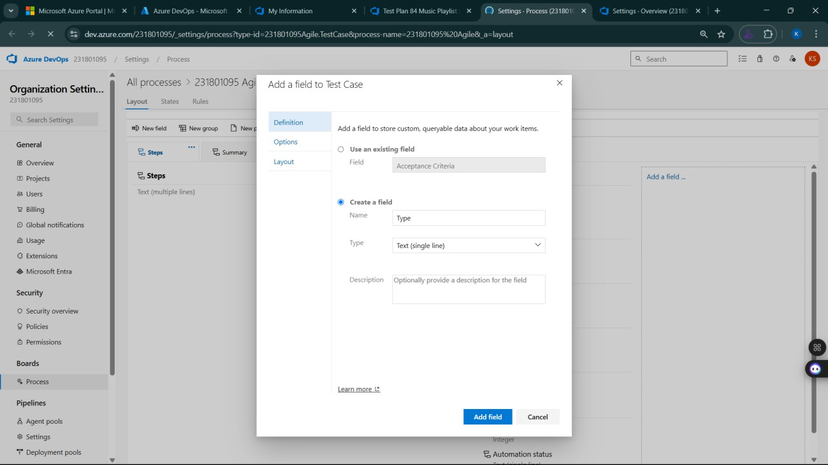

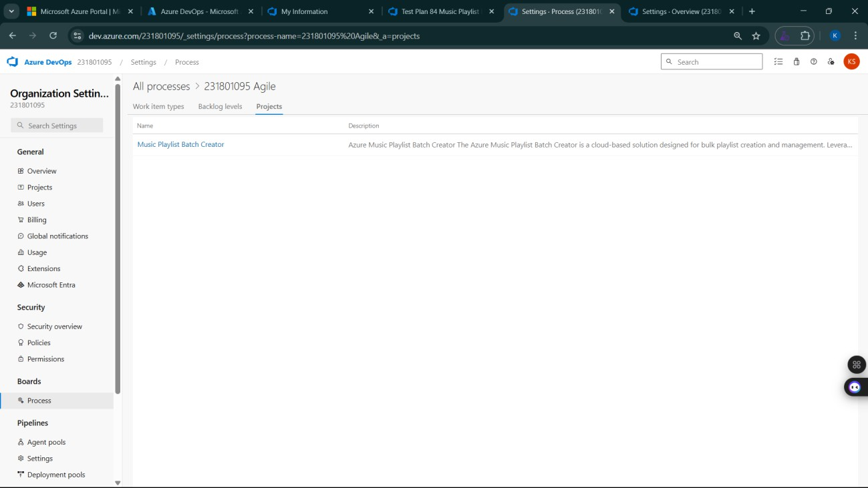

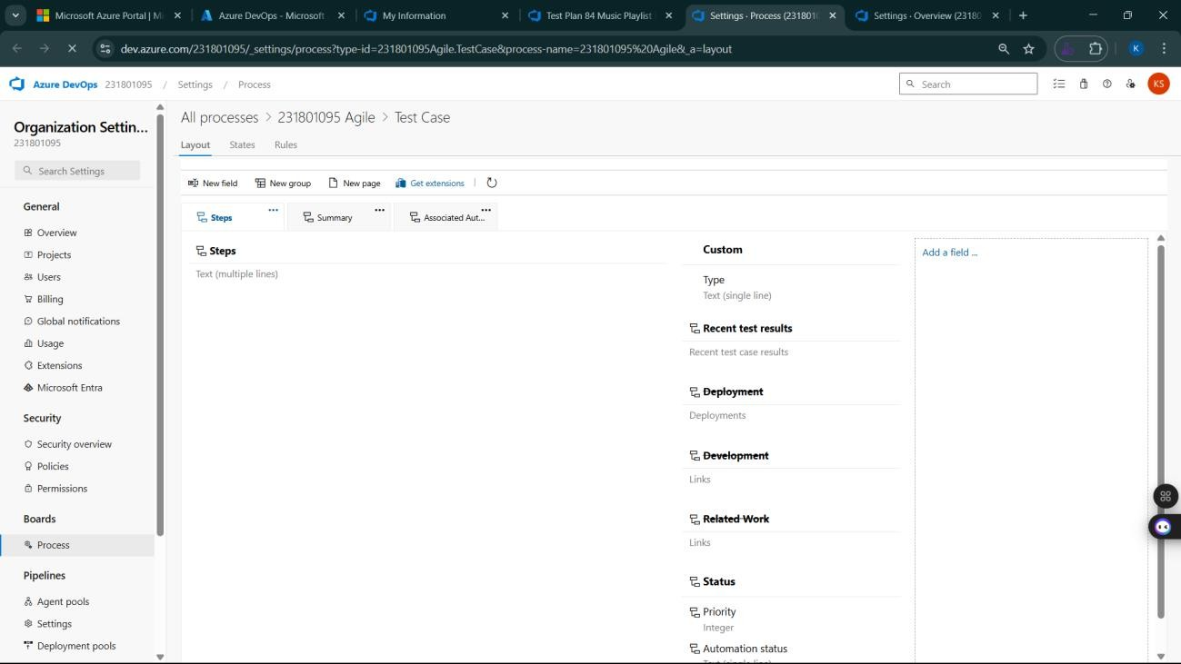

Result:
The test plans and test cases for the user stories is created in Azure DevOps with Happy Path and
Error Path

LOAD TESTING AND PIPELINES

EXP NO: 9

Aim:
Create Epic, Features, User Stories, Task
To create an Azure Load Testing resource and run a load test to evaluate the performance of a target endpoint and to create and demonstrate an Azure DevOps pipeline for automating application builds, tests, and deployment.

Load Testing
Azure Load Testing:
Azure Load Testing allows you to simulate high traffic and stress tests for your web applications and APIs to understand how they perform under load. It helps identify performance bottlenecks, scalability issues, and optimize resource usage before deployment.

Steps to Create an Azure Load Testing Resource:
Before you run your first test, you need to create the Azure Load Testing resource:
- Sign in to Azure Portal
Go to https://portal.azure.com and log in.
- Create the Resource
  - Go to Create a resource → Search for “Azure Load Testing”.
  - Select Azure Load Testing and click Create.
- Fill in the Configuration Details
  - Subscription: Choose your Azure subscription.
  - Resource Group: Create new or select an existing one.
  - Name: Provide a unique name (no special characters).
  - Location: Choose the region for hosting the resource.
- (Optional) Configure tags for categorization and billing.
- Click Review + Create, then Create.
- Once deployment is complete, click Go to resource.

Steps to Create and Run a Load Test:
Once your resource is ready:
- Go to your Azure Load Testing resource and click Add HTTP requests > Create.
- Basics Tab
  - Test Name: Provide a unique name.
  - Description: (Optional) Add test purpose.
  - Run After Creation: Keep checked.
- Load Settings
  - Test URL: Enter the target endpoint (e.g., https://team-genesis.netlify.app/).
- Click Review + Create → Create to start the test
Load Testing:
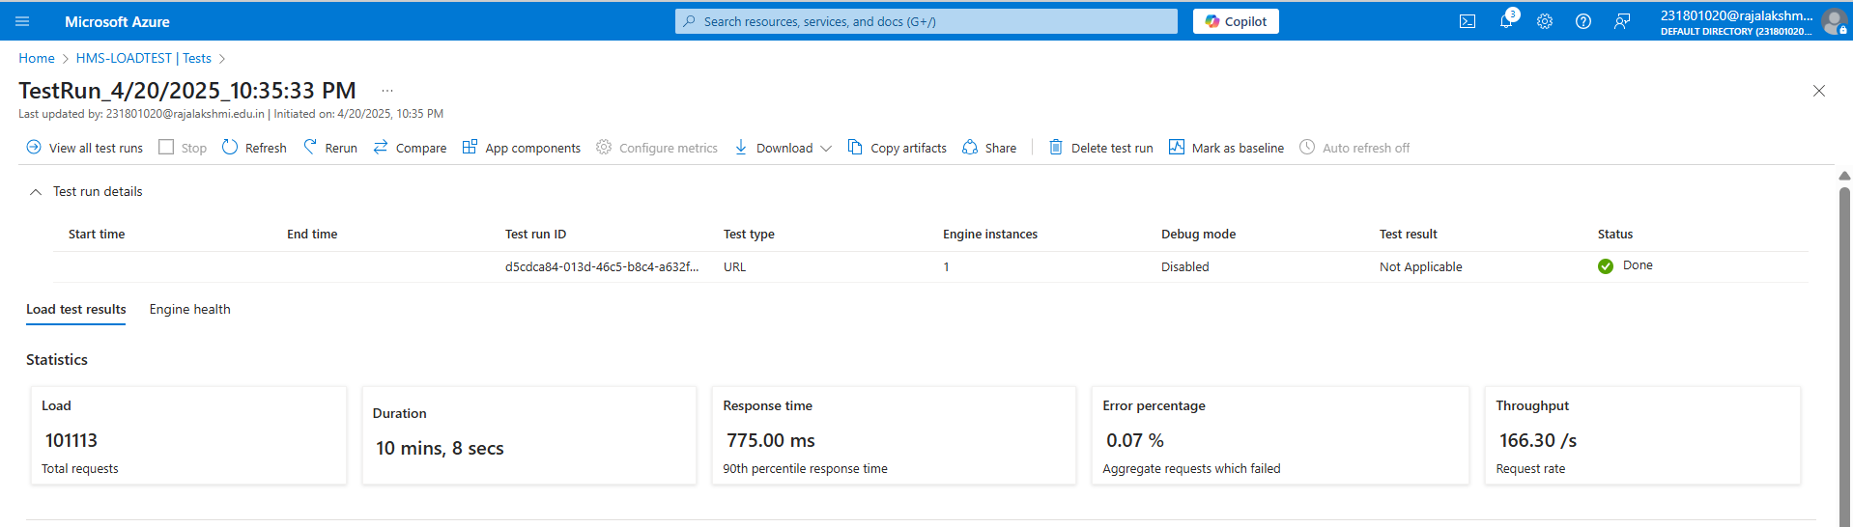
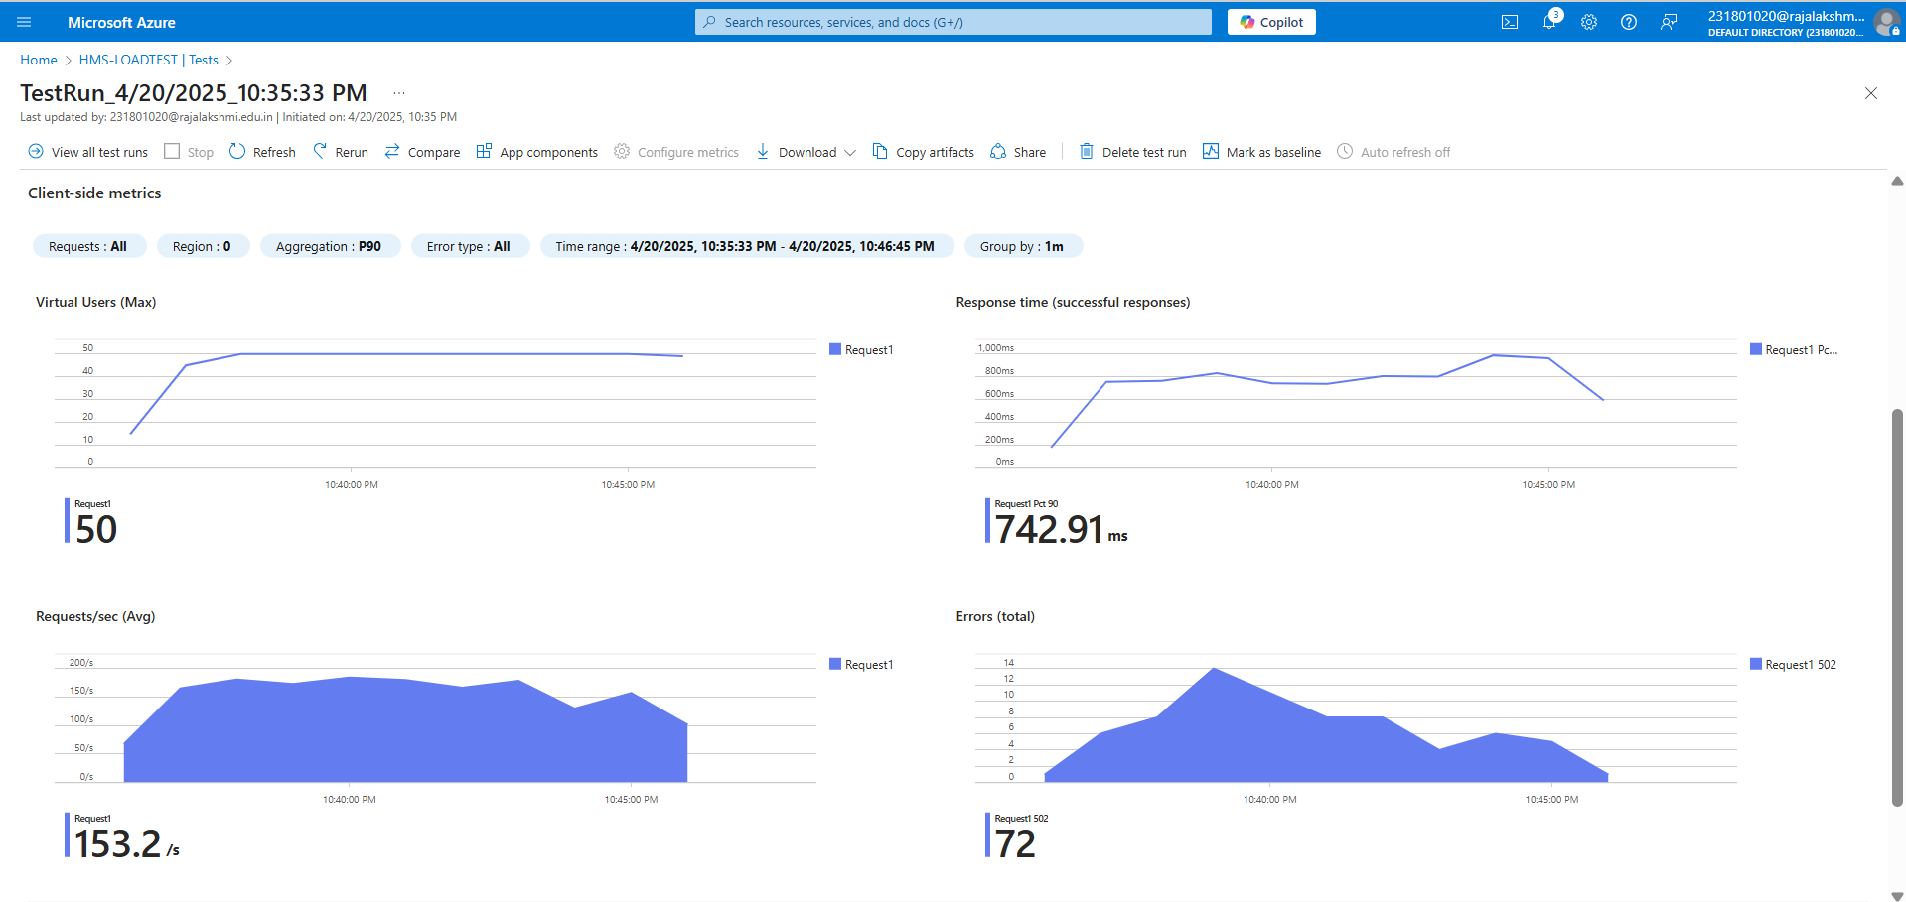

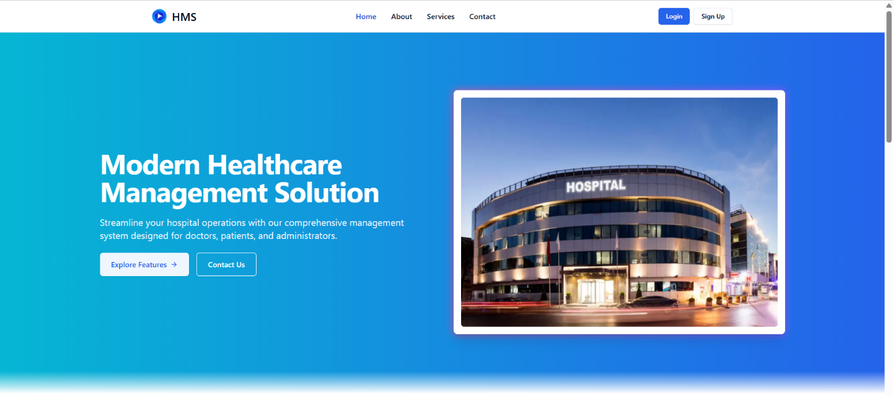
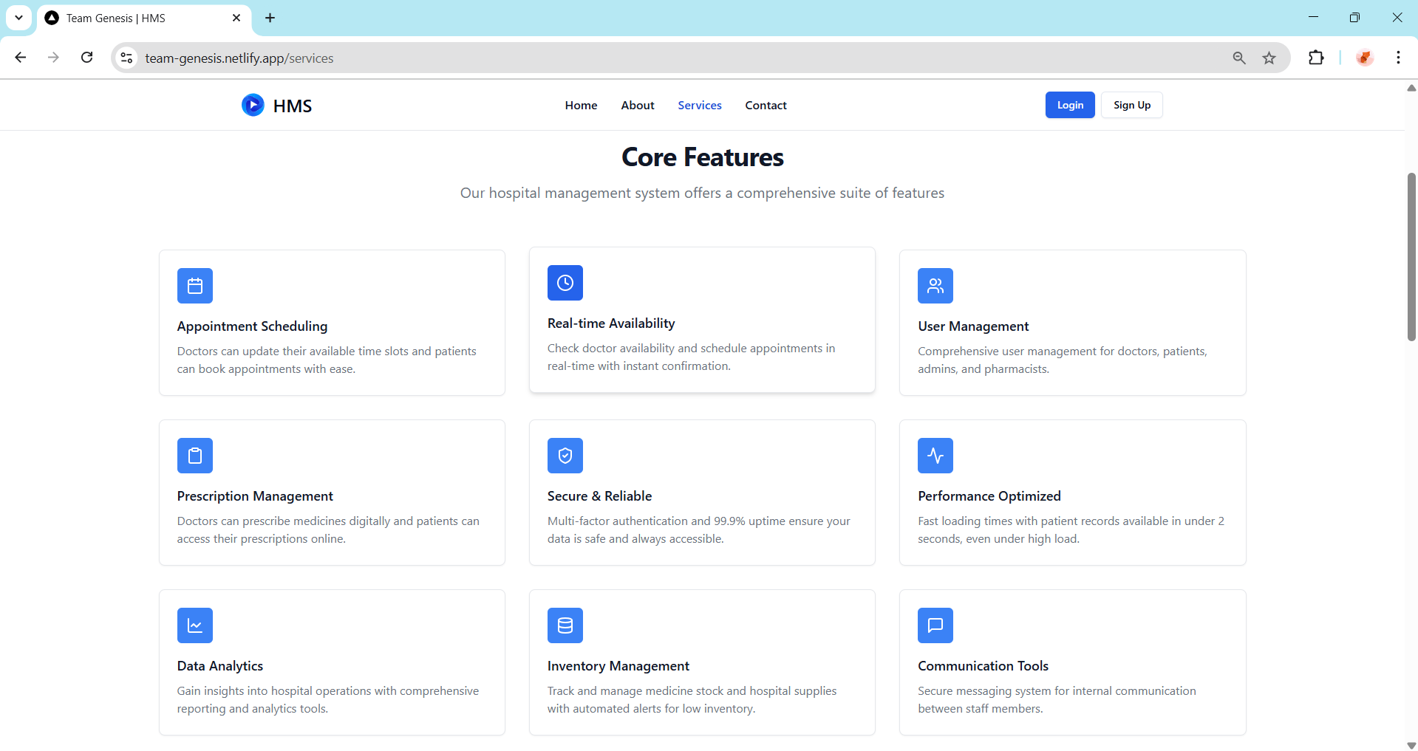
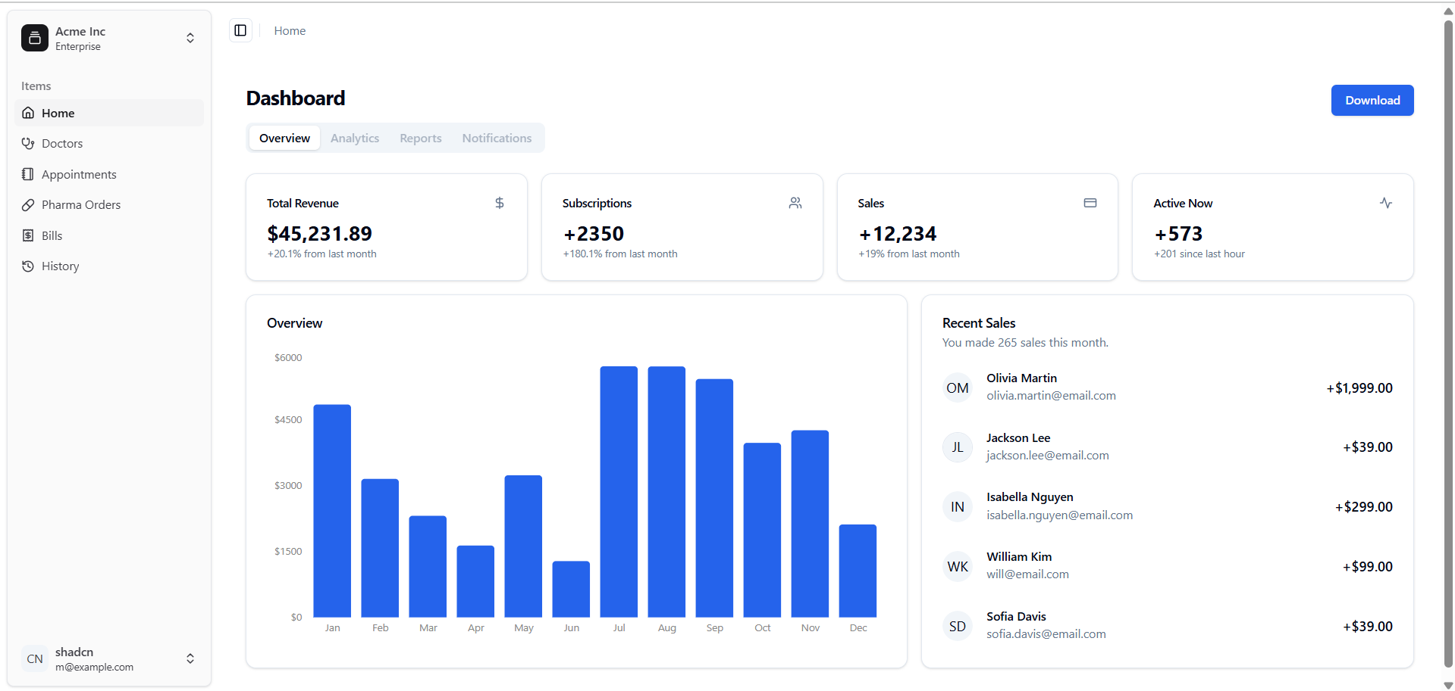

Pipelines: Description:
This experiment demonstrates how to connect a GitHub-hosted Flask-based music recommendation project with Azure DevOps. The pipeline will automatically install dependencies, run basic tests, and publish artifacts. This ensures that every commit triggers checks for reliability and smooth deployment.

Steps:
- Connect GitHub to Azure DevOps:
  - In Azure DevOps, create a new project.
  - Create a pipeline and select GitHub as the source.
  - Authorize access to your GitHub repository, ensuring that Azure DevOps can pull the repository for your pipeline.
- Create azure-pipelines.yml in Your Repo Root:
  - In your GitHub repository, create a new file called azure-pipelines.yml in the root directory.
  - Add the following basic pipeline configuration for Python and Flask:

yml Code:
trigger:
- main # Trigger pipeline when changes are pushed to the main branch

pool:
vmImage: ubuntu-latest # Use a hosted Ubuntu agent

steps:
# Step 1: Checkout the code from GitHub
- checkout: self

# Step 2: Set up Python environment
- task: UsePythonVersion@0 inputs:
versionSpec: '3.x' # Use the latest Python 3.x version displayName: "Set up Python"

# Step 3: Install dependencies from the correct path
- script: |
python -m pip install --upgrade pip
pip install -r project/requirements.txt # Adjusted path to requirements.txt displayName: "Install dependencies"

# Step 4: Run a simple Python script to check the environment
- script: |
python -c "print('J2¹Hello from Hospital Management System(HMS)!')" displayName: "Run a Python script"

- Pipeline Tasks Include:
  - Setting up the Python environment using the UsePythonVersion task.
  - Installing project dependencies from project/requirements.txt. Make sure the path to requirements.txt is correct (it is located under the project folder).
  - Running a simple Python script to verify that Python is set up correctly and the pipeline works.
- Run and Monitor Pipeline:
  - Commit changes to the main branch of your repository to trigger the pipeline in Azure DevOps.
  - Monitor the logs in the Azure DevOps portal to view logs, errors, or success messages and ensure everything runs smoothly.

Pipeline:

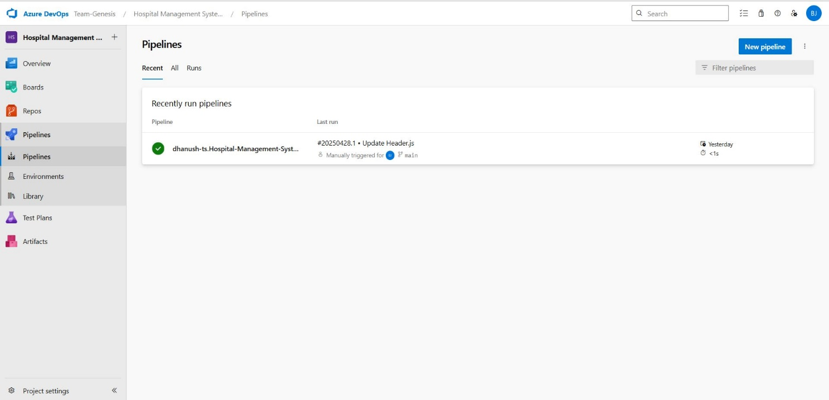

Result:
Successfully created the Azure Load Testing resource and executed a load test to assess the
performance of the specified endpoint and also demonstrated pipelines in Azure Devops.

GITHUB: PROJECT STRUCTURE & NAMING CONVENTIONS

EXP NO: 10

Aim:
Create Epic, Features, User Stories, Task
To provide a clear and organized view of the project's folder structure and file naming conventions, helping contributors and users easily understand, navigate, and extend the Hospital Management System project.

GitHub Project Structure:
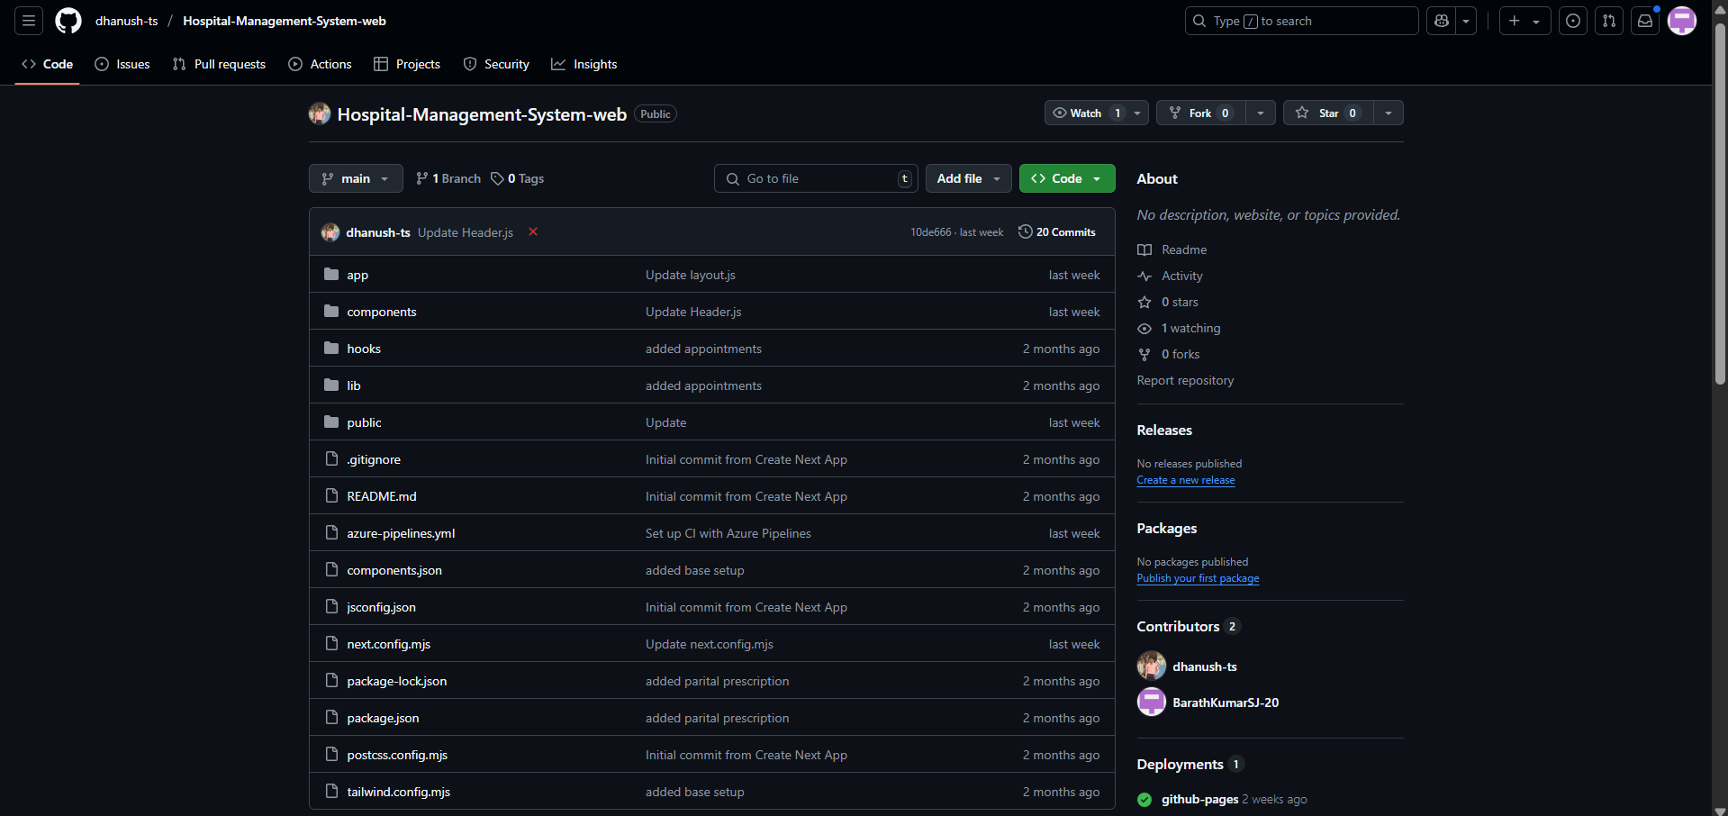

Result:
The GitHub repository clearly displays the organized project structure and consistent naming
conventions, making it easy for users and contributors to understand and navigate the codebase.

